

**FACULTY OF COMPUTING AND INFORMATICS**

**CSE6224 – SOFTWARE REQUIREMENTS ENG**

**GROUP: G07**

**SESSION: TT4L**

**PROJECT TITLE: University Communication and**

**Services Portal with Campus Management System and SMS Gateway Integration**

|  |  |
| --- | --- |
| **Student Name** | **Student ID** |
| Yang Jia En | 242UC2451Q |
| Teoh Xuan Xuan | 242UC2451P |
| Tey Jun Cheng | 242UC2452Z |

Submitted to: Dr. Zarina binti Che Embi

Date: 25 May 2025

**Table of Contents**

1.0 Introduction 4

1.1 Purpose 4

1.2 Scope 4

1.3 Product Overview 4

1.3.1 Product Perspective 4

1.3.2 Product Function 4

1.3.3 User Characteristics 4

1.3.4 Limitation 4

1.3.5 Apportioning of Requirements 4

1.4 Definition 4

2.0 Reference 5

3.0 Requirement 6

3.1 External Interface 6

3.1.1 6

3.1.2 6

3.2 Functions 6

3.2.1 Sequence Diagram 6

3.2.2 State Diagram 6

3.3 Functional Requirements 6

3.4 Performance Requirements 6

3.5 Usability Requirements 6

3.6 Interface Requirements 6

3.6.1 System Interface 6

3.6.2 User Interface 6

3.6.3 Hardware Interface 6

3.6.4 Software Interface 6

3.6.5 Communication Interface 6

3.6.6 Memory Constraints 6

3.6.7 Operation 6

3.6.8 Site Adaptation Requirements 6

3.6.9 Interface with Services 6

3.7 Logical Database Requirements 6

3.8 Design Constraints 6

3.9 Standard Compliance 7

3.10 Software System Attributes 7

3.10.1 Accuracy 7

3.10.2 Availability 7

3.10.3 Reliability 7

3.10.4 Security 7

3.10.5 Maintainability 7

3.10.6 Portability 7

3.10.7 Usability 7

3.11 Supporting Information 7

3.11.1 Prototyping 7

3.11.2 Questionnaire 7

3.11.3 Perspective-Based Reading 7

4.0 Verification 8

4.1 Verification Approach 8

4.2 Verification Criteria 8

4.3 Requirement Verification 8

4.3.1 Functional Requirements Verification 8

4.3.2 Performance Requirements Verification 8

4.3.3 Security Requirements Verification 8

4.3.4 Usability Requirements Verification 8

4.3.5 Maintainability Requirements Verification 8

4.3.6 Portability Requirements Verification 8

5.0 Appendices 8

5.1 Assumptions and Dependencies 8

5.2 Acronyms and Abbreviations 8

5.3 Glossary (Optional) 8

Change Log Table 9

# 1.0 Introduction

## 1.1 Purpose

The purpose of myMMU, the University Communication and Services Portal, is to serve as a centralized digital platform that streamlines communication and provides seamless access to academic and administrative services for the MMU community. By integrating with the Campus Management System and SMS Gateway, myMMU ensures that essential updates and academic information are delivered efficiently and effectively to students, lecturers, administrators, and parents.

At its core, myMMU is designed to enhance transparency, promote user engagement, and modernize institutional processes. Through this portal, students can view their academic performance, attendance records, financial statements, and important announcements. Parents are also kept informed with real-time SMS notifications about their child’s academic progress, fee reminders, and attendance alerts, enabling stronger parental involvement and support.

Additionally, lecturers and administrators benefit from streamlined workflows and direct communication channels, allowing them to focus more on delivering quality education and managing operations effectively. With its user-friendly interface and mobile accessibility, myMMU provides a consistent and inclusive digital experience for all stakeholders.

Ultimately, myMMU aims to bridge communication gaps, reduce administrative burden, and foster a more connected and responsive university environment. By embracing technological integration and real-time data sharing, this initiative marks a significant step forward in MMU’s digital transformation journey.

## 1.2 Scope

The myMMU University Communication and Services Portal will be a dynamic and centralized platform that connects students, lecturers, administrators, and parents within the MMU ecosystem. This platform is designed to provide secure access to academic records, attendance, billing information, announcements, and timely updates, while integrating with the university’s existing Campus Management System (CMS) and SMS Gateway.

At its core, myMMU will offer essential features to ensure that users can easily access and interact with academic and administrative services. Students will be able to view their academic performance, fee payment status, attendance records, and announcements in one place. Parents will receive SMS alerts on their children’s academic performance, absenteeism, and outstanding fees, promoting transparency and enabling better parental involvement.

Lecturers will be able to send announcements, monitor student attendance, and review academic progress, all through a simplified interface. Administrators will manage system configurations, broadcast campus-wide announcements, and ensure that the integration with the CMS and SMS Gateway runs smoothly.

To maintain an efficient and responsive service, myMMU will feature a modular design that supports future scalability, including multi-language support, theme personalization, and additional integrations (e.g., parking sticker services or timetable check-ins). The platform will also emphasize accessibility and responsiveness across desktop and mobile devices, ensuring a seamless experience for all users.

Furthermore, the system includes critical functions such as user authentication, role-based access control, SMS configuration, and secure data retrieval. These features ensure that myMMU not only meets core functional requirements but also satisfies institutional needs for data integrity, privacy, and real-time service delivery.

|  |  |
| --- | --- |
| User | Function |
| Student | 1. Check attendance Records 2. View billing info and payment status 3. Receive announcements and SMS alerts 4. Access timetable and course info |
| Parent | 1. Receive SMS alerts (low attendance, fee reminders, academic results) 2. View child's grades, attendance, billing info |
| Lecturer | 1. Post announcements and assignments 2. Upload materials 3. Update student's attendance and grades |
| Admin | 1. Post university-wide notifications 2. Approve classroom bookings |

Table 1.2.1: Scope of Functions by User Role in myMMU Portal

In conclusion, myMMU aims to redefine communication and service access within MMU by combining automation, transparency, and user-centric design. Its scope spans across academic, financial, and administrative domains, supporting the university’s digital transformation strategy and enhancing engagement among all stakeholders.

## 1.3 Product Overview

The myMMU University Communication and Services Portal is integrated with the university's Campus Management System and SMS Gateway, allowing students to access academic results, attendance records, billing information, and timetables. It also enables lecturers to submit grades and announcements, administrators to manage classroom bookings and inquiries, and parents to receive SMS alerts related to their child’s academic performance and financial obligations.

# **1.3.1 Product Perspective**

The myMMU University Communication and Services Portal is a centralized digital platform developed to enhance the academic and administrative experience for students, parents, lecturers, and university administrators. The system will be deployed on secure university-hosted infrastructure and will integrate directly with the Campus Management System (CMS) and an SMS Gateway, providing real-time access to essential information and direct mobile communication.

The myMMU system functions as an extension of the university's digital ecosystem, consolidating various services—such as academic performance tracking, attendance management, billing, and announcements—into one user-friendly interface. Each user role is provided with tailored access to relevant features, ensuring a secure, role-based experience.

The platform will be accessible through modern web browsers on desktop and mobile devices, promoting ease of access and usability. Students can retrieve personalized academic data and book classrooms, while parents receive timely SMS updates on their child’s academic status and financial obligations. Lecturers can push announcements, submit grades, and manage assessments. Administrators will oversee platform configuration, handle booking approvals, and broadcast campus-wide notifications.

To ensure performance and scalability, the system architecture includes:

1. A Web Server for handling user requests and interfaces.
2. A Database Server for storing academic, billing, and attendance data.
3. Secure integration with the Campus Management System for data synchronization.
4. A connection to the SMS Gateway for outbound alerts and reminders.

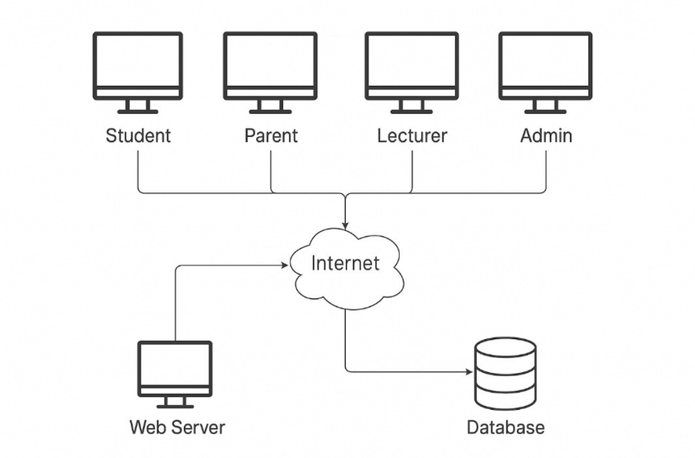

Figure 1.3.1 System Overview Diagram

The integration with the CMS ensures that academic records and billing data are always up to date, while the SMS Gateway guarantees that critical messages reach recipients in real time. This design supports the university’s goals of digital transformation, transparent communication, and academic excellence by offering a holistic and modern service platform.

context diagram

#### 1.3.1.1 System Interface

myMMU connects directly to:

* Campus Management System (CMS) for retrieving academic results, billing information, attendance, and timetable data.
* SMS Gateway to deliver notifications such as low attendance alerts, fee reminders, and performance summaries to users.
* Internal MMU authentication systems for credential validation and session handling.

#### 1.3.1.2 User Interface

The portal provides:

* A responsive web interface for desktops, tablets, and smartphones.
* Role-based dashboards (Student, Parent, Lecturer, Admin).
* A simple, accessible layout with icons, labels, and tables for data display and interaction.
* Language support: English (default), with potential for multi-language extension.

#### 1.3.1.3 Hardware Interface

* Client Devices: Any modern device with internet access (PCs, laptops, tablets, smartphones).
* Server Infrastructure: University-hosted or cloud-based servers that store and manage data, API connections, and file storage.
* Compatible with USB card readers or biometric login in the future (optional).

#### 1.3.1.4 Software Interface

* Built using Laravel/PHP or Django/Python for the backend.
* Relies on RESTful APIs to communicate with CMS and SMS services.
* Uses MySQL/PostgreSQL for database storage.
* Browser Compatibility: Latest versions of Chrome, Firefox, Edge, and Safari.

#### 1.3.1.5 Communication Interface

* All communication between the client and server occurs over HTTPS.
* Internal API communication uses JSON over REST.
* SMS alerts are triggered via a secure gateway with OTP/token-based authentication.

#### 1.3.1.6 Memory Constraints

* Minimal client-side memory usage as the application runs in-browser.
* Server specifications:
* Minimum 4GB RAM (test/development)
* Recommended 8GB+ RAM with scalable cloud storage for production

#### 1.3.1.7 Operation

* The system is operational 24/7, except during planned maintenance.
* Role-based access ensures that users only interact with relevant modules.
* Real-time data updates are ensured through scheduled syncing with CMS.

#### 1.3.1.8 Site Adaptation

* The system can be rebranded for different university branches (logo, colors, tagline).
* Configurable time zone, academic calendar, and localization.
* Scalable for future modules (e.g., club management, wellness tracking).

#### 1.3.1.9 Interface with Services

myMMU interfaces with:

* Campus Management System: Academic records, fees, timetable, and attendance.
* SMS Gateway: For outbound communication.
* Authentication Service: For secure login and session management.
* Optional: Email server or notification system for email alerts.

# **1.3.2 Product Function**

This is the overall use case diagram that show all use case for all actors.

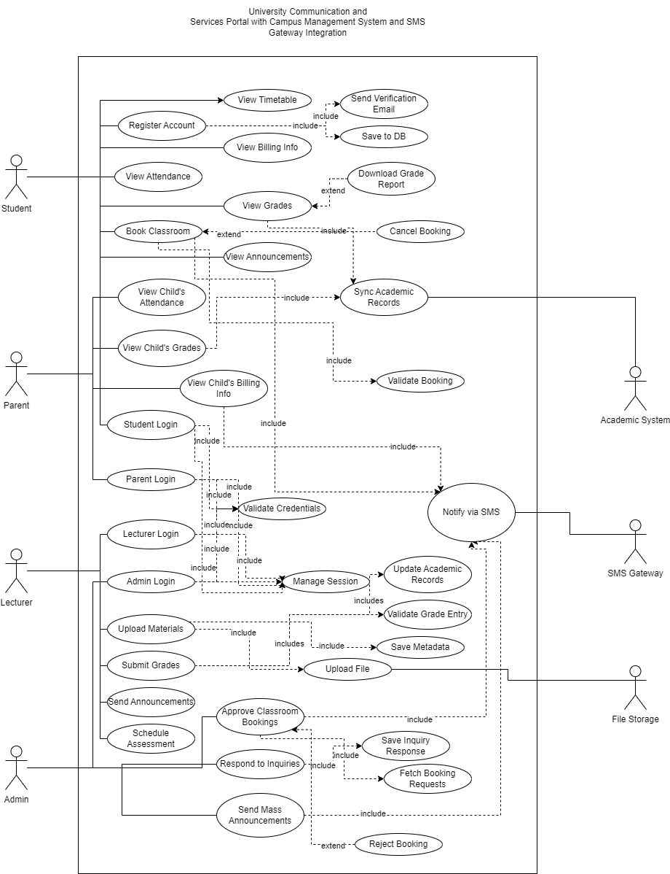

Figure 1.3.2: Use Case Diagram of myMMU University Communication and Services Portal

#### 1.3.2.1 Student

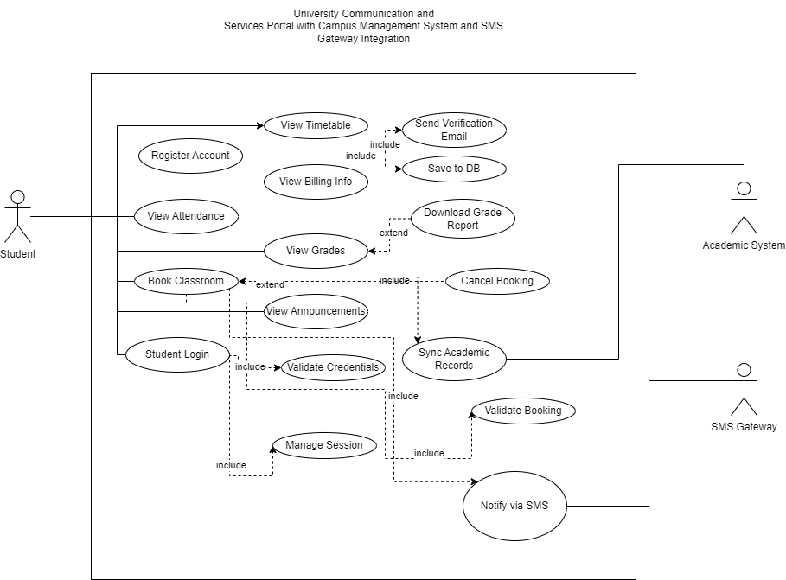

Figure 1.3.2.1: Use Case Diagram of Actor (Student)

|  |  |  |  |
| --- | --- | --- | --- |
| **Use Case ID** | **Use Case Name** | **Description** | **Author** |
| REQ_STD001 | Student Login | Allows a student to log into the system using valid credentials. | Your Name |
| REQ_STD002 | Register Account | Enables new users to register and create a student account. | Your Name |
| REQ_STD003 | View Grades | Allows students to view their academic results and download reports. | Your Name |
| REQ_STD004 | View Attendance | Enables students to check their attendance records. | Your Name |
| REQ_STD005 | View Timetable | Allows students to access their academic schedule. | Your Name |
| REQ_STD006 | View Billing Info | Enables students to check outstanding fees and payment history. | Your Name |
| REQ_STD007 | Book Classroom | Allows students to reserve a classroom based on availability. | Your Name |
| REQ_STD008 | View Announcements | Enables students to view announcements posted by lecturers or admins. | Your Name |
| REQ_STD009 | Download Grade Report | Allows students to download a detailed grade report. *(<> from View Grades)* | Your Name |
| REQ_STD010 | Cancel Booking | Permits students to cancel a previously booked classroom. *(<> from Book Classroom)* | Your Name |
| REQ_STD011 | Notify via SMS | Sends SMS notifications regarding fees, attendance, or grades. *(integrated with SMS Gateway)* | Your Name |

#### 1.3.2.2 Lecturer

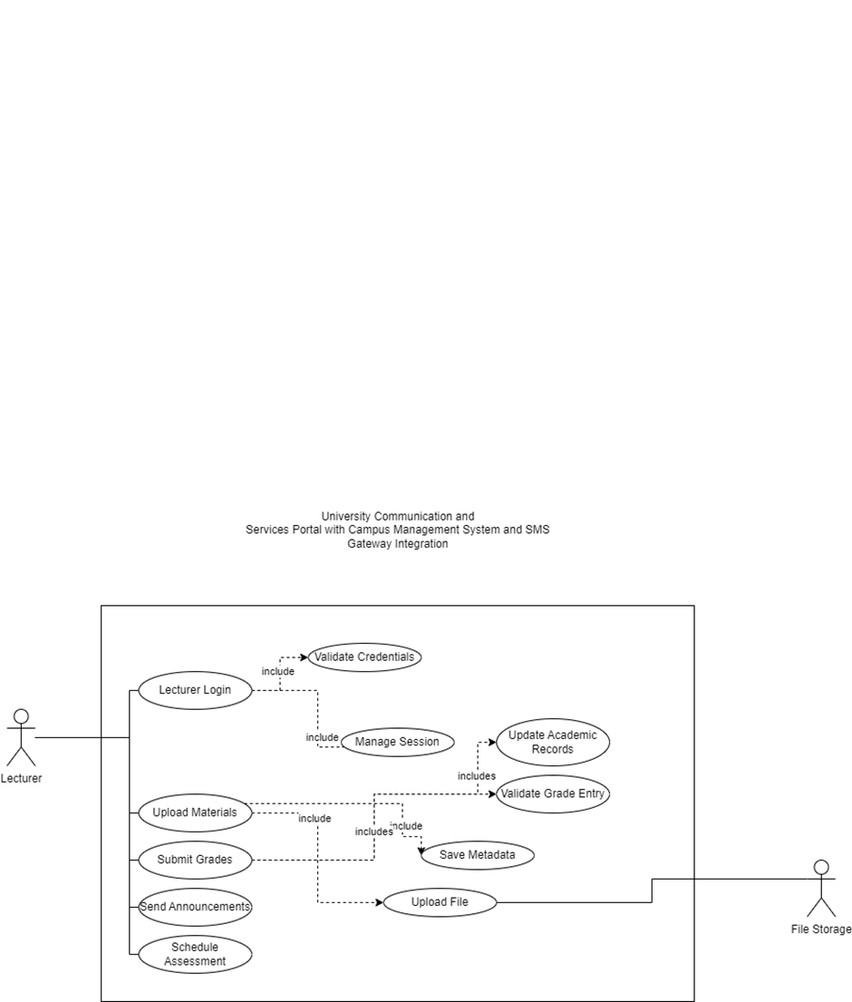

Figure 1.3.2.1: Use Case Diagram of Actor (Lecturer)

|  |  |  |  |
| --- | --- | --- | --- |
| **Use Case ID** | **Use Case Name** | **Description** | **Author** |
| REQ_LEC001 | Lecturer Login | Allows lecturers to log into the system securely using their credentials. | Your Name |
| REQ_LEC002 | Upload Materials | Enables lecturers to upload lecture notes, slides, and supporting documents for students. | Your Name |
| REQ_LEC003 | Submit Grades | Allows lecturers to input and submit students’ academic results. | Your Name |
| REQ_LEC004 | Send Announcements | Enables lecturers to broadcast announcements to their respective classes. | Your Name |
| REQ_LEC005 | Schedule Assessment | Allows lecturers to set and manage assessment dates for assignments, quizzes, or exams. | Your Name |

#### 1.3.2.3 Admin

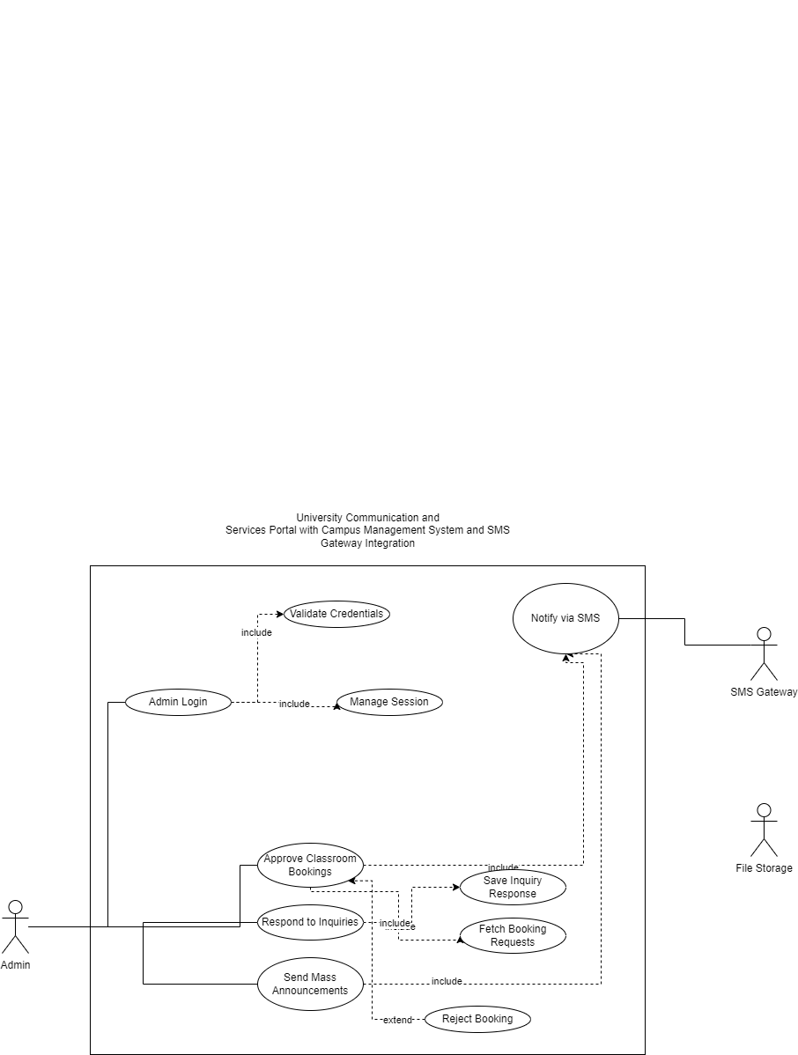

Figure 1.3.2.1: Use Case Diagram of Actor (Admin)

|  |  |  |  |
| --- | --- | --- | --- |
| **Use Case ID** | **Use Case Name** | **Description** | **Author** |
| REQ_LEC001 | Lecturer Login | Allows lecturers to log into the system securely using their credentials. | Your Name |
| REQ_LEC002 | Upload Materials | Enables lecturers to upload lecture notes, slides, and supporting documents for students. | Your Name |
| REQ_LEC003 | Submit Grades | Allows lecturers to input and submit students’ academic results. | Your Name |
| REQ_LEC004 | Send Announcements | Enables lecturers to broadcast announcements to their respective classes. | Your Name |
| REQ_LEC005 | Schedule Assessment | Allows lecturers to set and manage assessment dates for assignments, quizzes, or exams. | Your Name |

#### 1.3.2.4 Parent

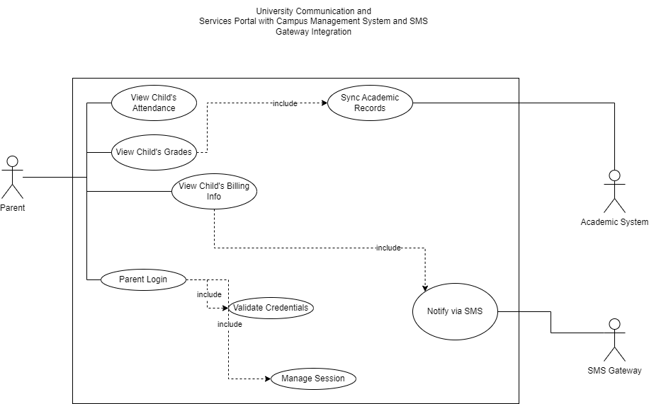

Figure 1.3.2.1: Use Case Diagram of Actor (Parent)

|  |  |  |  |
| --- | --- | --- | --- |
| **Use Case ID** | **Use Case Name** | **Description** | **Author** |
| REQ_PAR001 | Parent Login | Allows parents to securely log into the portal using their credentials. | Your Name |
| REQ_PAR002 | View Child’s Grades | Enables parents to access and review their child’s academic performance. | Your Name |
| REQ_PAR003 | View Child’s Attendance | Allows parents to monitor their child’s attendance records. | Your Name |
| REQ_PAR004 | View Child’s Billing Info | Permits parents to view their child’s outstanding fees and payment status. | Your Name |

# **1.3.3 User Characteristics**

This section outlines the characteristics of each intended user group in the myMMU portal. It includes the users’ roles, expected familiarity with technology, and the level of system interaction. Understanding these traits helps guide interface design, user onboarding, and support strategy.

|  |  |  |  |
| --- | --- | --- | --- |
| Role | Description | Status | Technical Expertise / Expected Knowledge |
| **Student** | Current students enrolled in the university using the portal for academic and service access. | User Privilege | Basic to moderate understanding of online portals, ability to check academic data, and perform transactions. |
| **Parent** | Guardians or parents who monitor their child’s academic and financial status. | User Privilege | Basic mobile usage, familiar with SMS and simple dashboard interfaces. |
| **Lecturer** | Teaching staff who submit results, upload materials, and communicate with students. | User Privilege | Moderate understanding of system tools like grade entry, document upload, and class-wide messaging. |
| **Admin** | University staff responsible for managing bookings, inquiries, and announcements. | Developer Privilege | Advanced system knowledge, administrative dashboard handling, and SMS broadcast or approval workflows. |

Table 1.3.3: User Characteristics of myMMU System

### 1.3.4 Limitation

The development and deployment of the myMMU University Communication and Services Portal come with several limitations that could affect its functionality, user experience, and maintainability. These limitations arise from technical constraints, integration dependencies, user behavior, and resource availability.

1. Hardware Limitations

The system’s performance may vary depending on the university’s existing server infrastructure and client devices used by end-users. Outdated hardware on either side may result in slower processing times, delayed data synchronization with the Campus Management System (CMS), or degraded user experience.

2. Integration Dependencies

myMMU depends heavily on its integration with external systems such as the CMS and the SMS Gateway. Any changes, downtime, or API limitations from these external systems could directly affect the portal’s functionality, requiring frequent updates or workaround implementations.

3. Security and Privacy Constraints

Ensuring the protection of academic and financial data is critical. The system must comply with university policies and data protection regulations. Failure to implement robust authentication, encryption, and access control measures could lead to data breaches, loss of trust, and system vulnerabilities.

4. User Adoption and Technological Familiarity

The portal’s effectiveness depends on its active usage by students, parents, lecturers, and administrators. Low user awareness, resistance to adopting new platforms, or unfamiliarity with system navigation could hinder engagement and reduce the system’s impact.

5. Customization and Scalability

While the portal is designed to be modular, certain university-specific features may not be easily customizable due to platform architecture constraints. Adapting the system to evolving university needs or expanding it to other campuses may require significant redevelopment.

6. Budget and Resource Constraints

The development, deployment, and maintenance of myMMU must operate within the university’s budget. Limited financial or human resources may restrict the implementation of advanced features, multilingual support, or real-time analytics, impacting the system’s growth and sustainability.

### 1.3.5 Apportioning of Requirements

The apportioning of requirements for the myMMU University Communication and Services Portal categorizes the system into key functional modules. Each module targets a specific aspect of the portal’s core features, ensuring that stakeholder needs are met efficiently through structured development. The following table outlines the requirement allocation across major system modules:

|  |  |  |
| --- | --- | --- |
| **Module ID** | **Module Name** | **Description** |
| REQ_MMU001 | User Management | Handles account registration, login, authentication, session handling, and role-based access control. |
| REQ_MMU002 | Academic Records Module | Manages retrieval and display of grades, attendance, timetable, and billing information via CMS. |
| REQ_MMU003 | Classroom Booking | Allows students to submit booking requests; enables admins to approve, reject, or cancel bookings. |
| REQ_MMU004 | Announcement Module | Supports lecturers and admins in creating and broadcasting announcements to students. |
| REQ_MMU005 | SMS Notification System | Sends real-time SMS alerts to parents and students on performance, attendance, or fee updates. |
| REQ_MMU006 | Data Sync and Integration | Handles integration with the Campus Management System and SMS Gateway for syncing academic data. |

Table 1.3.5: Apportioning of Requirements

## 1.4 Definition

Below are important terms used in the myMMU Software Requirements Specification (SRS), along with their respective definitions.

|  |  |
| --- | --- |
| **Term** | **Definition** |
| **myMMU** | A centralized portal for university communication and academic/administrative services. |
| **User** | Any individual who uses the system, including students, parents, lecturers, and administrators. |
| **Student** | A current MMU student who can access personal academic and financial data via the portal. |
| **Parent** | A guardian or parent who receives updates on the student’s academic progress and fee status. |
| **Lecturer** | University staff responsible for managing classes, assessments, grades, and announcements. |
| **Administrator** | A user with system-level privileges to manage bookings, respond to inquiries, and send alerts. |
| **Campus Management System (CMS)** | The university’s existing back-end system storing academic, billing, and attendance data. |
| **SMS Gateway** | An external service used to send real-time SMS alerts to parents and students. |
| **Dashboard** | A personalized user interface displaying relevant modules based on the user’s role. |
| **Authentication** | The login process where users provide credentials to access the system securely. |

Table 1.4: Terms and Definitions

# Reference

Mikulić, J. and Prebežac, D. (2011), "A critical review of techniques for classifying quality attributes in the Kano model", Managing Service Quality: An International Journal, Vol. 21 No. 1, pp. 46-66. <https://doi.org/10.1108/09604521111100243>

# 3.0 Requirement

# **3.1 Functions**

### 3.1.1 Login

## Table 3.1.1: User login use case specification table

|  |  |
| --- | --- |
| **ID** | **F-001** |
| **Feature** | Login |
| **Version** | 1.0 |
| **Purpose** | To allow students, parents, lecturers, and admins to securely log in to the myMMU portal and access relevant services. |
| **Actor(s)** | Student, Parent, Lecturer, Admin |
| **Precondition** | User must have a valid user ID and password. |
| **Postcondition** | User will be authenticated and redirected to their respective dashboard based on role. |
| **Main Flow** | 1. Actor navigates to Login Page 2. System displays Login Page 3. Actor enters user ID and password 4. System verifies credentials 5. System authenticates user and starts session 6. System redirects actor to respective dashboard |
| **Alternate Scenario** | 1. If credentials are invalid, system shows error message and asks for re-entry 2. If fields are empty, system displays error prompting for all required fields |
| **Author** | [Your Name Here] |

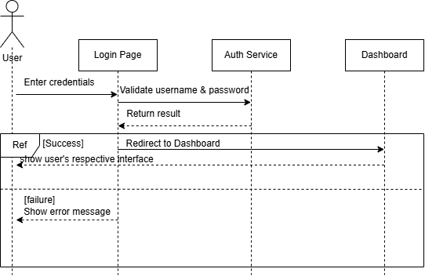

Figure 3.1.1.1: User login sequence diagram

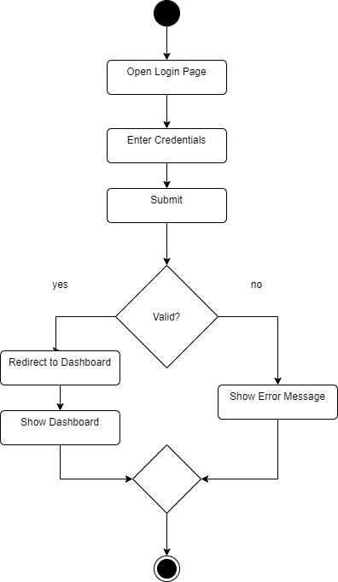

Figure 3.1.1.2: User login activity diagram

### 3.1.2 View Grades

Table 3.1.2: User view grades use case specification table

|  |  |
| --- | --- |
| **ID** | **F-001** |
| **Feature** | View Grades |
| **Version** | 1.1 |
| **Purpose** | To allow users to view a student’s academic performance retrieved from the university CMS. |
| **Actor(s)** | Student, Parent, Admin |
| **Precondition** | Actor must be logged in and have valid permissions. |
| **Postcondition** | Grades for the selected trimester or subject are displayed. |
| **Main Flow** | 1. Actor navigates to "Grades" page 2. System requests grade data from CMS 3. System filters and formats data based on the actor’s role 4. System displays grades in a readable format |
| **Alternate Scenario** | 1. If CMS is unavailable, system shows "Unable to retrieve grades" 2. If student has no grades recorded, system shows "No grades available" |
| **Author** | [Your Name Here] |

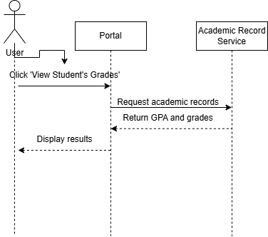

Figure 3.1.2.1: User view grades sequence diagram

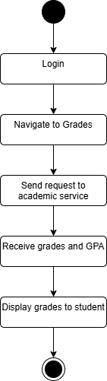

Figure 3.1.2.1: User view grades activity diagram

### 3.1.3 View attendance ( except Lecturer )

Table 3.1.3: User view attendance use case specification table

|  |  |
| --- | --- |
| **ID** | **F-001** |
| **Feature** | View Attendance |
| **Version** | 1.0 |
| **Purpose** | To allow students, parents, and admins to view a student's attendance records retrieved from the university CMS. |
| **Actor(s)** | Student, Parent, Admin |
| **Precondition** | Actor must be logged in with appropriate permissions. |
| **Postcondition** | Attendance records are displayed for the selected subject and timeframe. |
| **Main Flow** | 1. Actor navigates to "Attendance" page 2. System retrieves attendance data from CMS 3. System filters and formats the data 4. System displays attendance summary and details to the actor |
| **Alternate Scenario** | 1. If CMS connection fails, system displays "Unable to fetch attendance data" 2. If no attendance records exist, system shows "No attendance available" |
| **Author** | [Your Name Here] |

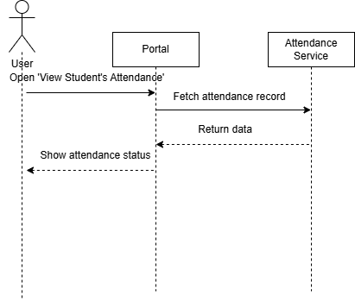

Figure 3.1.3.1:

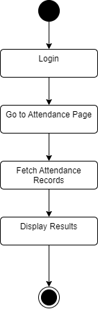

Figure 3.1.3.1:

### 3.1.4 Student and Parent View Billing Info

Table

|  |  |
| --- | --- |
| **ID** | **F-001** |
| **Feature** | View Billing Information |
| **Version** | 1.0 |
| **Purpose** | To allow students and parents to view the student’s financial records, including outstanding fees, payment status, and history. |
| **Actor(s)** | Student, Parent |
| **Precondition** | Actor must be logged in with a valid session. |
| **Postcondition** | The billing summary and detailed breakdown are displayed. |
| **Main Flow** | 1. Actor navigates to "Billing Info" page 2. System fetches billing data from CMS 3. System displays the summary of fees, due dates, and payment history |
| **Alternate Scenario** | 1. If billing data is unavailable, system shows "Unable to retrieve billing information" 2. If no records exist, system shows "No billing records found" |
| **Author** | [Your Name Here] |

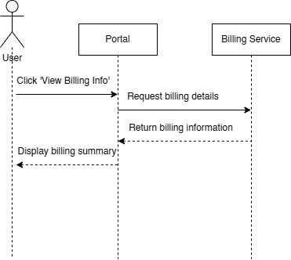

Figure

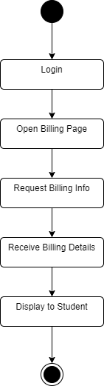

Figure

### 3.1.5 Student View Timetable

Table

|  |  |
| --- | --- |
| **ID** | **F-001** |
| **Feature** | View Timetable |
| **Version** | 1.0 |
| **Purpose** | To allow students to view their class schedules based on the current or selected trimester, retrieved from the university’s CMS. |
| **Actor(s)** | Student |
| **Precondition** | Student must be logged in with an active session. |
| **Postcondition** | Timetable is displayed based on selected filters (e.g., week, trimester). |
| **Main Flow** | 1. Student selects "Timetable" tab 2. System fetches timetable data from CMS based on student ID and trimester 3. System formats timetable 4. System displays schedule in calendar/grid view |
| **Alternate Scenario** | 1. If no timetable is available, system shows "No timetable data found" 2. If CMS fetch fails, system shows error and retry option |
| **Author** | [Your Name Here] |

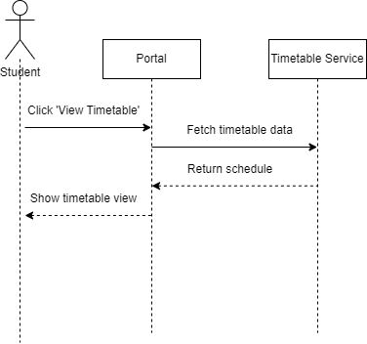

Figure

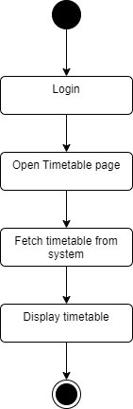

Figure

### 3.1.6 Student View Announcements

Table

|  |  |
| --- | --- |
| **ID** | **F-001** |
| **Feature** | View Announcements |
| **Version** | 1.0 |
| **Purpose** | To allow students to access official announcements such as academic notices, deadlines, events, or important updates. |
| **Actor(s)** | Student |
| **Precondition** | Student must be logged in with a valid session. |
| **Postcondition** | Relevant announcements are displayed to the student. |
| **Main Flow** | 1. Student clicks on “Announcements” tab 2. System fetches announcements from database or CMS 3. System filters announcements based on category or target audience 4. System displays announcement list with preview 5. Student clicks an item to view full content |
| **Alternate Scenario** | 1. If there are no announcements, system displays “No announcements available” 2. If retrieval fails, system shows “Unable to load announcements” |
| **Author** | [Your Name Here] |

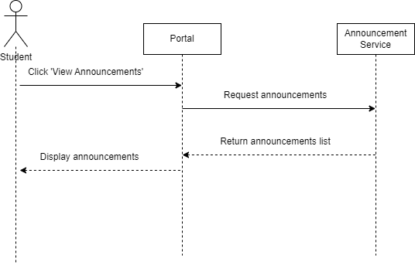

Figure

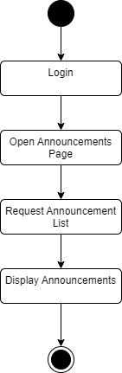

Figure

### 3.1.7 Student Book Classroom

Table

|  |  |
| --- | --- |
| **ID** | **F-001** |
| **Feature** | Book Classroom |
| **Version** | 1.0 |
| **Purpose** | To allow students to submit a request to book a classroom for group study or project meetings. |
| **Actor(s)** | Student |
| **Precondition** | Student must be logged in with a valid session. |
| **Postcondition** | Booking request is submitted and pending admin approval. |
| **Main Flow** | 1. Student navigates to "Book Classroom" page 2. Student selects date, time, and room 3. System validates availability 4. Student submits request 5. System records request and forwards to Admin for approval 6. System displays booking status as “Pending” |
| **Alternate Scenario** | 1. If the room is unavailable, system prompts student to select another slot 2. If submission fails, system shows “Booking request failed. Please try again.” |
| **Author** | [Your Name Here] |

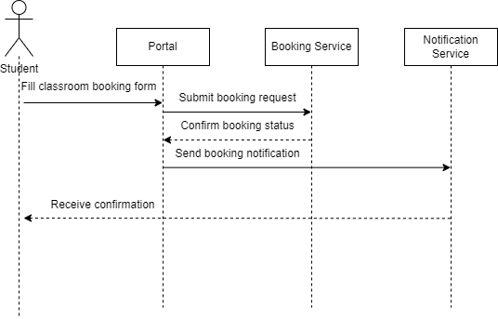

Figure

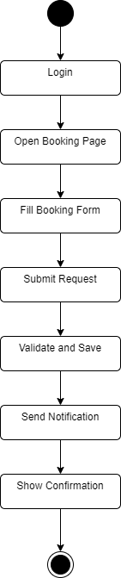

Figure

### 3.1.8 User Receive Notification

Table

|  |  |
| --- | --- |
| **ID** | **F-001** |
| **Feature** | Receive SMS Notification |
| **Version** | 1.0 |
| **Purpose** | To notify students and parents via SMS when key events occur, such as grade release, low attendance alerts, or unpaid fees. |
| **Actor(s)** | Student, Parent |
| **Precondition** | Actor has a valid phone number registered in the system. |
| **Postcondition** | Actor receives SMS with relevant content. |
| **Main Flow** | 1. System detects triggering event (e.g., grade posted) 2. System checks notification rules 3. System composes SMS message 4. System sends SMS via integrated SMS Gateway 5. Actor receives SMS on mobile device |
| **Alternate Scenario** | 1. If phone number is missing or invalid, system logs the failure 2. If SMS Gateway is unavailable, system queues or retries the message |
| **Author** | [Your Name Here] |

Missing seq & actvity

### 3.1.9 Lecturer Upload Materials

Table

|  |  |
| --- | --- |
| **ID** | **F-001** |
| **Feature** | Upload Materials |
| **Version** | 1.0 |
| **Purpose** | To allow lecturers to upload learning materials such as slides, notes, or readings for students to access. |
| **Actor(s)** | Lecturer |
| **Precondition** | Lecturer must be logged in and assigned to a subject. |
| **Postcondition** | Materials are stored and made accessible to enrolled students. |
| **Main Flow** | 1. Lecturer navigates to “Upload Materials” page 2. Lecturer selects subject and uploads file 3. System validates file type/size 4. System stores file in server or cloud storage 5. System logs upload and displays confirmation |
| **Alternate Scenario** | 1. If file is too large or invalid format, system rejects and prompts correction 2. If upload fails due to network/server issues, system shows “Upload failed, please try again” |
| **Author** | [Your Name Here] |

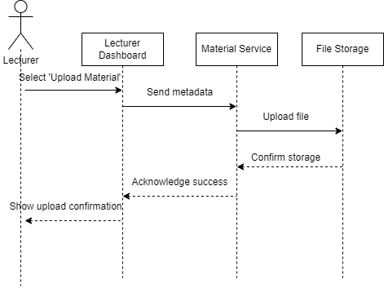

Figure

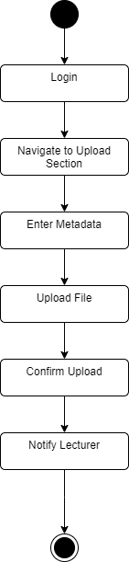

Figure

### 3.1.10 Lecturer Submit Grades

Table

|  |  |
| --- | --- |
| **ID** | **F-001** |
| **Feature** | Submit Grades |
| **Version** | 1.0 |
| **Purpose** | To allow lecturers to enter, update, and submit student grades for subjects they are teaching. |
| **Actor(s)** | Lecturer |
| **Precondition** | Lecturer must be logged in and assigned to the subject. |
| **Postcondition** | Student grades are stored in the system and synced with the academic records. |
| **Main Flow** | 1. Lecturer navigates to “Submit Grades” page 2. Lecturer selects subject and trimester 3. Lecturer inputs or uploads grades for enrolled students 4. System validates input (e.g., valid range, complete fields) 5. System saves grades and confirms submission |
| **Alternate Scenario** | 1. If invalid data is entered, system shows errors for correction 2. If submission fails (e.g., server or sync error), system shows retry prompt |
| **Author** | [Your Name Here] |

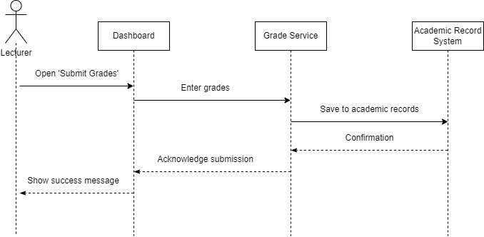

Figure

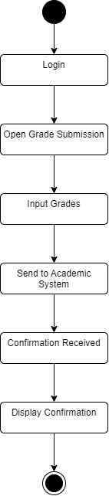

Figure

### 3.1.11 Lecturer Send Announcements

Table

|  |  |
| --- | --- |
| **ID** | **F-001** |
| **Feature** | Send Announcements |
| **Version** | 1.0 |
| **Purpose** | To allow lecturers to send academic announcements to students enrolled in their subjects. |
| **Actor(s)** | Lecturer |
| **Precondition** | Lecturer must be logged in and assigned to at least one subject. |
| **Postcondition** | Announcement is delivered to relevant students and stored in the system. |
| **Main Flow** | 1. Lecturer navigates to “Send Announcements” 2. Lecturer selects subject and enters message 3. System validates content and target audience 4. System saves announcement and sends it to all enrolled students 5. Students see the announcement on their dashboards |
| **Alternate Scenario** | 1. If message field is empty or too long, system prompts for correction 2. If submission fails due to server error, system shows “Unable to send announcement” |
| **Author** | [Your Name Here] |

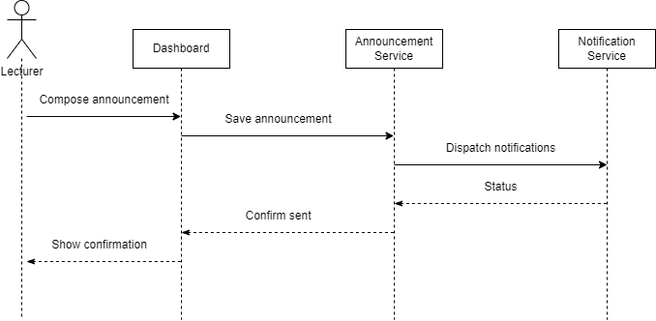

Figure

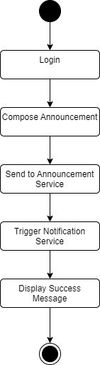

Figure

### 3.1.11 Lecturer Send Announcements

Table

|  |  |
| --- | --- |
| **ID** | **F-001** |
| **Feature** | Send Announcements |
| **Version** | 1.0 |
| **Purpose** | To allow lecturers to send academic announcements to students enrolled in their subjects. |
| **Actor(s)** | Lecturer |
| **Precondition** | Lecturer must be logged in and assigned to at least one subject. |
| **Postcondition** | Announcement is delivered to relevant students and stored in the system. |
| **Main Flow** | 1. Lecturer navigates to “Send Announcements” 2. Lecturer selects subject and enters message 3. System validates content and target audience 4. System saves announcement and sends it to all enrolled students 5. Students see the announcement on their dashboards |
| **Alternate Scenario** | 1. If message field is empty or too long, system prompts for correction 2. If submission fails due to server error, system shows “Unable to send announcement” |
| **Author** | [Your Name Here] |



Figure



Figure

### 3.1.12 Lecturer Schedule Assessment

Table

|  |  |
| --- | --- |
| **ID** | **F-001** |
| **Feature** | Schedule Assessment |
| **Version** | 1.0 |
| **Purpose** | To allow lecturers to schedule upcoming assessments such as quizzes, tests, or presentations for their students. |
| **Actor(s)** | Lecturer |
| **Precondition** | Lecturer must be logged in and assigned to a subject. |
| **Postcondition** | Assessment schedule is saved and displayed to relevant students. |
| **Main Flow** | 1. Lecturer navigates to “Schedule Assessment” page 2. Lecturer selects subject and assessment type 3. Lecturer sets date, time, and venue or online mode 4. System validates the input 5. System stores assessment and notifies students |
| **Alternate Scenario** | 1. If time slot or venue is unavailable, system prompts to choose another 2. If submission fails due to system error, system shows retry prompt |
| **Author** | [Your Name Here] |

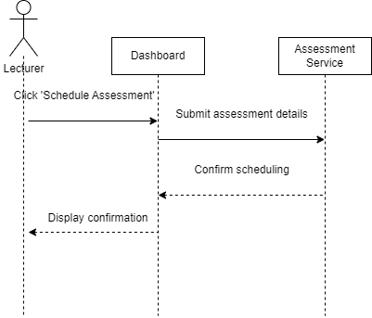

Figure

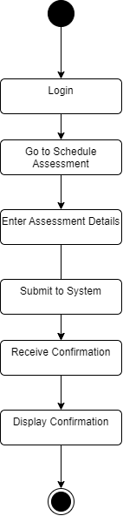

Figure

### 3.1.13 Admin Approve Class Booking

Table

|  |  |
| --- | --- |
| **ID** | **F-001** |
| **Feature** | Approve Classroom Booking |
| **Version** | 1.0 |
| **Purpose** | To allow administrators to review and approve or reject classroom booking requests submitted by students. |
| **Actor(s)** | Admin |
| **Precondition** | Admin must be logged in and have access to booking requests. |
| **Postcondition** | Booking status is updated to “Approved” and student is notified. |
| **Main Flow** | 1. Admin navigates to “Classroom Booking Requests” 2. System displays pending requests with booking details 3. Admin reviews details and approves booking 4. System updates booking status to “Approved” 5. System sends confirmation to student |
| **Alternate Scenario** | 1. If room is no longer available, system prompts admin to reject or suggest alternate slot 2. If system fails to update status, admin is notified of the error |
| **Author** | [Your Name Here] |

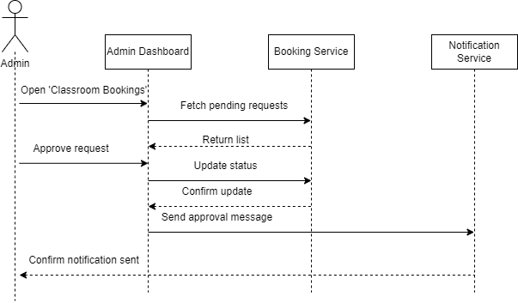

Figure

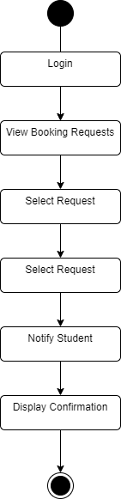

Figure

### 3.1.14 Admin Send Mass Announcements

Table

|  |  |
| --- | --- |
| **ID** | **F-001** |
| **Feature** | Send Mass Announcements |
| **Version** | 1.0 |
| **Purpose** | To allow administrators to broadcast important announcements to all users or specific groups (students, parents, lecturers). |
| **Actor(s)** | Admin |
| **Precondition** | Admin must be logged in with appropriate permissions. |
| **Postcondition** | Announcement is sent to the selected user group(s) and stored in the system. |
| **Main Flow** | 1. Admin navigates to “Send Mass Announcements” page 2. Admin selects target audience (e.g., All Students, All Users) 3. Admin writes the announcement content 4. System validates input 5. System stores the announcement and dispatches it to user dashboards or via SMS (if enabled) |
| **Alternate Scenario** | 1. If no target group is selected or message is empty, system prompts for correction 2. If message dispatch fails, system shows error and logs the issue |
| **Author** | [Your Name Here] |

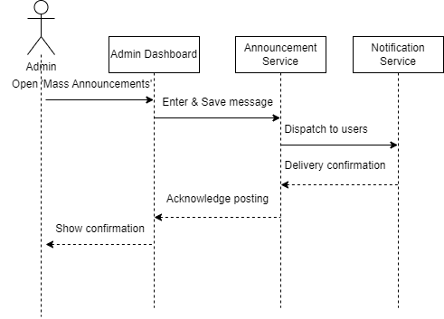

Figure

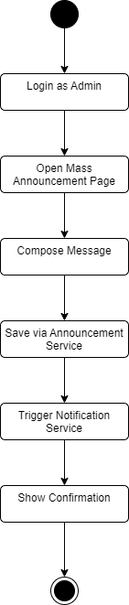

Figure

## 3.2 Functional Requirements

This section outlines the system’s required functionalities and behaviors to fulfill the needs of users and stakeholders. It specifies the essential operations, features, and interactions the system must support to achieve its goals. The table below presents a detailed list of all functional requirements, ensuring the system can operate efficiently and deliver its intended outcomes.

Table 3.2: Functional requirements table

|  |  |  |  |
| --- | --- | --- | --- |
| **Requirement ID** | **Description** | **Priority** | **Author** |
| REQ_F001 | The system shall allow students and parents to view academic performance, attendance, and billing information retrieved from the Campus Management System. | High | [Your Name Here] |
| REQ_F002 | The system shall allow students to view timetables and exam schedules in a unified dashboard. | High | [Your Name Here] |
| REQ_F003 | The system shall allow lecturers to upload materials and submit grades, and students to download materials. | High | [Your Name Here] |
| REQ_F004 | The system shall allow students to book classrooms and allow admins to approve or reject bookings. | Medium | [Your Name Here] |
| REQ_F005 | The system shall allow users to receive SMS notifications about academic performance, low attendance, and fee reminders. | High | [Your Name Here] |
| REQ_F006 | The system shall allow parents to view their child’s grades, attendance, and billing info. | High | [Your Name Here] |
| REQ_F007 | The system shall allow the admin to send system-wide announcements to students, parents, and lecturers. | Medium | [Your Name Here] |
| REQ_F008 | The system shall generate and send deadline reminders via email/SMS for assessments and fee payments. | Medium | [Your Name Here] |
| REQ_F009 | The system shall support content approval workflow for admin-moderated announcements and booking requests. | Medium | [Your Name Here] |

## 3.3 Performance Requirements

This section outlines the quality benchmarks the system must meet to ensure optimal performance. The platform is expected to deliver reliable, efficient, and responsive services to all users, including students, lecturers, administrators, and parents. It should support high availability, low latency, and consistent performance even during peak usage. The table below summarizes the specific performance requirements for the system.

Table 3.3: Performance requirements table

|  |  |  |  |
| --- | --- | --- | --- |
| **Requirement ID** | **Description** | **Priority** | **Author** |
| REQ_P001 | The system shall respond to user actions (login, view pages) within 1 to 2 seconds. | High | [Your Name Here] |
| REQ_P002 | The system shall support up to 5,000 concurrent users without degradation in performance. | High | [Your Name Here] |
| REQ_P003 | The system shall maintain at least 99.9% uptime, excluding scheduled maintenance periods. | High | [Your Name Here] |
| REQ_P004 | The system shall retrieve and display student academic and billing data within 2 seconds. | Medium | [Your Name Here] |
| REQ_P005 | The system shall process and send SMS notifications (e.g. fee alerts, attendance warnings) within 1 second of triggering. | High | [Your Name Here] |
| REQ_P006 | The system shall allow parents to access child-related academic records within 3 seconds. | Medium | [Your Name Here] |
| REQ_P007 | The system shall generate downloadable grade reports within 5 seconds. | Medium | [Your Name Here] |
| REQ_P008 | The system shall handle real-time classroom booking requests and return confirmation results within 2 seconds. | High | [Your Name Here] |
| REQ_P009 | The system shall ensure minimal latency (<100ms) in communication between front-end and the Campus Management System APIs. | High | [Your Name Here] |
| REQ_P010 | The system shall be accessible and stable across mobile and desktop platforms, with consistent performance. | Medium | [Your Name Here] |

## 3.4 Usability Requirements

This section outlines the usability goals that the system aims to achieve to ensure a smooth and satisfying user experience. These requirements are designed to improve accessibility, reduce user effort, and enhance user engagement for students, lecturers, parents, and administrators. The table below lists all usability requirements with their descriptions and priorities.

Table 3.4: Usability requirements table

|  |  |  |  |
| --- | --- | --- | --- |
| **Requirement ID** | **Description** | **Priority** | **Author** |
| REQ_U001 | The platform shall provide a clean, consistent, and intuitive interface for all users to easily access academic and administrative services. | High | [Your Name Here] |
| REQ_U002 | The system interface shall clearly label menu items such as Grades, Attendance, Timetable, and Billing for easy navigation. | Medium | [Your Name Here] |
| REQ_U003 | The interface shall maintain a consistent color scheme and font usage to minimize distraction and support accessibility. | High | [Your Name Here] |
| REQ_U004 | The platform shall be responsive and mobile-friendly, allowing smooth access on phones, tablets, and desktops. | High | [Your Name Here] |
| REQ_U005 | The platform shall display real-time feedback for actions such as form submissions, file uploads, or failed actions. | High | [Your Name Here] |
| REQ_U006 | The system shall support clear visual cues (icons, colors) for system alerts like pending payments or low attendance warnings. | High | [Your Name Here] |
| REQ_U007 | The platform shall allow students and parents to preview downloadable files (e.g., grade reports, fee statements) before downloading. | Low | [Your Name Here] |
| REQ_U008 | The platform shall provide accessible features such as screen reader support and high-contrast mode for visually impaired users. | High | [Your Name Here] |

## 3.5 Interface Requirements

### 3.5.1 IO01 Sign In Page

|  |  |
| --- | --- |
| **Requirement ID** | **REQ_IO0101** |
| **Version** | 1.0 |
| **Item** | Sign In Button (Input) |
| **Item Description** | A button labelled “Sign In” |
| **Item Purpose** | To submit the login form for authentication |
| **Input Format** | Button |
| **Valid Input** | Not Applicable |
| **Related I/O** | REQ_IO0102, REQ_IO0103 |
| **Author** | [Your Name Here] |

|  |  |
| --- | --- |
| **Requirement ID** | **REQ_IO0102** |
| **Version** | 1.0 |
| **Item** | User ID Field (Input) |
| **Item Description** | A text field labelled “User ID” |
| **Item Purpose** | To capture the user’s assigned login ID |
| **Input Format** | String |
| **Valid Input** | Alphanumeric string (6–20 chars) |
| **Related I/O** | REQ_IO0101 |
| **Author** | [Your Name Here] |

|  |  |
| --- | --- |
| **Requirement ID** | **REQ_IO0103** |
| **Version** | 1.0 |
| **Item** | Password Field (Input) |
| **Item Description** | A masked field for password input |
| **Item Purpose** | To receive the user’s login password |
| **Input Format** | String |
| **Valid Input** | ASCII characters, 8–20 chars |
| **Related I/O** | REQ_IO0101 |
| **Author** | [Your Name Here] |

|  |  |
| --- | --- |
| **Requirement ID** | **REQ_IO0104** |
| **Version** | 1.0 |
| **Item** | Remember Me Checkbox (Input) |
| **Item Description** | A checkbox to optionally remember login session |
| **Item Purpose** | To keep users logged in between sessions |
| **Input Format** | Checkbox |
| **Valid Input** | Checked / Unchecked |
| **Related I/O** | REQ_IO0101 |
| **Author** | [Your Name Here] |

|  |  |
| --- | --- |
| **Requirement ID** | **REQ_IO0105** |
| **Version** | 1.0 |
| **Item** | Forgot Password Link |
| **Item Description** | A clickable link that redirects to the password recovery page |
| **Item Purpose** | To allow users to recover their account credentials |
| **Input Format** | Hyperlink |
| **Valid Input** | Click event |
| **Related I/O** | REQ_IO0102 |
| **Author** | [Your Name Here] |

|  |  |
| --- | --- |
| **Requirement ID** | **REQ_IO0106** |
| **Version** | 1.0 |
| **Item** | Error Message Display |
| **Item Description** | Displays "Email/Password does not match!" if login fails |
| **Item Purpose** | To inform user about incorrect login credentials |
| **Input Format** | Display Text |
| **Valid Input** | N/A (System generated) |
| **Related I/O** | REQ_IO0101 |
| **Author** | [Your Name Here] |

### 3.5.2 IO02 Student Dashboard Page

|  |  |
| --- | --- |
| **Requirement ID** | **REQ_IO0201** |
| **Version** | 1.0 |
| **Item** | Enrolled Courses Display (Output) |
| **Item Description** | Displays cards showing course name, lecturer, class days, time, and location |
| **Item Purpose** | To inform students of their current enrolled subjects and timetable |
| **Input Format** | Display Panel |
| **Valid Input** | N/A |
| **Related I/O** | Academic Records API |
| **Author** | [Your Name Here] |

|  |  |
| --- | --- |
| **Requirement ID** | **REQ_IO0202** |
| **Version** | 1.0 |
| **Item** | Exam Board Table (Output) |
| **Item Description** | Tabular display of exam name, course, date, time, location, and status |
| **Item Purpose** | To provide students with exam schedules and status updates |
| **Input Format** | Table |
| **Valid Input** | N/A |
| **Related I/O** | Exam Schedule Module |
| **Author** | [Your Name Here] |

|  |  |
| --- | --- |
| **Requirement ID** | **REQ_IO0203** |
| **Version** | 1.0 |
| **Item** | Navigation Sidebar (Input) |
| **Item Description** | List of clickable links: Main, Personal Information, University Subjects, Academic Records, Campus Finances, Campus Lifestyle, Announcements |
| **Item Purpose** | To allow students to navigate between core sections of the portal |
| **Input Format** | Clickable Link |
| **Valid Input** | Click events |
| **Related I/O** | All main page modules |
| **Author** | [Your Name Here] |

|  |  |
| --- | --- |
| **Requirement ID** | **REQ_IO0204** |
| **Version** | 1.0 |
| **Item** | View All Button (Input) |
| **Item Description** | A small button/link labeled "View All" near Enrolled Courses and Exam Board |
| **Item Purpose** | To expand the section or redirect users to a full page view |
| **Input Format** | Button/Link |
| **Valid Input** | Click event |
| **Related I/O** | REQ_IO0201, REQ_IO0202 |
| **Author** | [Your Name Here] |

|  |  |
| --- | --- |
| **Requirement ID** | **REQ_IO0205** |
| **Version** | 1.0 |
| **Item** | Log Out Link (Input) |
| **Item Description** | A text-based button allowing the user to log out of the session |
| **Item Purpose** | To end the user session and redirect to login page |
| **Input Format** | Link |
| **Valid Input** | Click event |
| **Related I/O** | Session Manager |
| **Author** | [Your Name Here] |

### 3.5.3 IO03 View Billing Page

|  |  |
| --- | --- |
| **Requirement ID** | **REQ_IO0301** |
| **Version** | 1.0 |
| **Item** | Billing Summary Table (Output) |
| **Item Description** | A table displaying billing details by trimester including date, term, transaction term, due date, and total fee |
| **Item Purpose** | To give users a quick overview of outstanding or past billing by term |
| **Input Format** | Table |
| **Valid Input** | N/A |
| **Related I/O** | REQ_IO0302 |
| **Author** | [Your Name Here] |

|  |  |
| --- | --- |
| **Requirement ID** | **REQ_IO0302** |
| **Version** | 1.0 |
| **Item** | Search for Trimester Field (Input) |
| **Item Description** | A text search box to filter billing summary by trimester |
| **Item Purpose** | To allow users to search for a specific term’s billing |
| **Input Format** | Text field |
| **Valid Input** | Alphanumeric (e.g. “March/April 2025”) |
| **Related I/O** | REQ_IO0301 |
| **Author** | [Your Name Here] |

|  |  |
| --- | --- |
| **Requirement ID** | **REQ_IO0303** |
| **Version** | 1.0 |
| **Item** | Make Payment Button (Input) |
| **Item Description** | A button that redirects to an external payment or billing system |
| **Item Purpose** | To initiate the fee payment process |
| **Input Format** | Button |
| **Valid Input** | Click event |
| **Related I/O** | External billing system |
| **Author** | [Your Name Here] |

|  |  |
| --- | --- |
| **Requirement ID** | **REQ_IO0304** |
| **Version** | 1.0 |
| **Item** | Detailed Billing Table (Output) |
| **Item Description** | A table showing all individual charges for a selected trimester: date, invoice number, item, subject, due date, charge, and status |
| **Item Purpose** | To allow users to understand specific charges and their status |
| **Input Format** | Table |
| **Valid Input** | N/A |
| **Related I/O** | REQ_IO0301 |
| **Author** | [Your Name Here] |

|  |  |
| --- | --- |
| **Requirement ID** | **REQ_IO0305** |
| **Version** | 1.0 |
| **Item** | Print Bill Button (Input) |
| **Item Description** | A button labeled "Print Bill" that generates a printable version of the detailed bill |
| **Item Purpose** | To allow students or parents to print the fee breakdown |
| **Input Format** | Button |
| **Valid Input** | Click event |
| **Related I/O** | REQ_IO0304 |
| **Author** | [Your Name Here] |

### 3.5.4 IO04 View Grades Page

|  |  |
| --- | --- |
| **Requirement ID** | **REQ_IO0401** |
| **Version** | 1.0 |
| **Item** | Grade Table (Output) |
| **Item Description** | A table displaying each subject’s code, name, trimester, and final grade |
| **Item Purpose** | To allow students and parents to view academic performance for each subject |
| **Input Format** | Table |
| **Valid Input** | N/A |
| **Related I/O** | Academic Record API |
| **Author** | [Your Name Here] |

|  |  |
| --- | --- |
| **Requirement ID** | **REQ_IO0402** |
| **Version** | 1.0 |
| **Item** | Trimester Filter Dropdown (Input) |
| **Item Description** | A dropdown menu listing trimesters (e.g., "March 2024", "Oct 2024") |
| **Item Purpose** | To allow users to filter grades by specific term |
| **Input Format** | Dropdown |
| **Valid Input** | Trimester ID |
| **Related I/O** | REQ_IO0401 |
| **Author** | [Your Name Here] |

|  |  |
| --- | --- |
| **Requirement ID** | **REQ_IO0403** |
| **Version** | 1.0 |
| **Item** | Download Grade Report Button (Input) |
| **Item Description** | A button that generates and downloads a PDF grade report |
| **Item Purpose** | To allow students to save or print their results |
| **Input Format** | Button |
| **Valid Input** | Click event |
| **Related I/O** | Report Generator |
| **Author** | [Your Name Here] |

### 3.5.5 IO05 View Announcements Page

|  |  |
| --- | --- |
| **Requirement ID** | **REQ_IO0501** |
| **Version** | 1.0 |
| **Item** | Announcement List (Output) |
| **Item Description** | A vertical list showing announcement title, date, and a preview of content |
| **Item Purpose** | To inform users (students, parents, lecturers) of important university-wide updates |
| **Input Format** | Display list |
| **Valid Input** | N/A |
| **Related I/O** | Announcements API |
| **Author** | [Your Name Here] |

|  |  |
| --- | --- |
| **Requirement ID** | **REQ_IO0502** |
| **Version** | 1.0 |
| **Item** | View Full Announcement Link (Input) |
| **Item Description** | A clickable link/button that expands or redirects to the full announcement details |
| **Item Purpose** | To allow users to view the complete content of an announcement |
| **Input Format** | Link or Button |
| **Valid Input** | Click event |
| **Related I/O** | REQ_IO0501 |
| **Author** | [Your Name Here] |

|  |  |
| --- | --- |
| **Requirement ID** | **REQ_IO0503** |
| **Version** | 1.0 |
| **Item** | Filter by Role/Category (Input) |
| **Item Description** | Dropdown or toggle to filter announcements (e.g., for students, parents, lecturers) |
| **Item Purpose** | To display only relevant announcements based on user type |
| **Input Format** | Dropdown / Toggle |
| **Valid Input** | Role/category ID |
| **Related I/O** | REQ_IO0501 |
| **Author** | [Your Name Here] |

### 3.5.6 IO06 View Attendance Page

|  |  |
| --- | --- |
| **Requirement ID** | **REQ_IO0601** |
| **Version** | 1.0 |
| **Item** | Attendance Record Table (Output) |
| **Item Description** | A table displaying subject code, subject name, percentage attended, total sessions, attended sessions |
| **Item Purpose** | To provide students and parents with a detailed view of attendance per subject |
| **Input Format** | Table |
| **Valid Input** | N/A |
| **Related I/O** | Attendance Module |
| **Author** | [Your Name Here] |

|  |  |
| --- | --- |
| **Requirement ID** | **REQ_IO0602** |
| **Version** | 1.0 |
| **Item** | Filter by Trimester (Input) |
| **Item Description** | A dropdown to filter attendance records by trimester |
| **Item Purpose** | To allow users to view attendance data for a specific term |
| **Input Format** | Dropdown |
| **Valid Input** | Trimester value (e.g. March 2025) |
| **Related I/O** | REQ_IO0601 |
| **Author** | [Your Name Here] |

|  |  |
| --- | --- |
| **Requirement ID** | **REQ_IO0603** |
| **Version** | 1.0 |
| **Item** | Status Indicator (Output) |
| **Item Description** | Colored labels or icons indicating status (e.g., Good, Warning, Low) based on attendance percentage |
| **Item Purpose** | To give visual cues to users about attendance risk levels |
| **Input Format** | Display icon/text |
| **Valid Input** | N/A (System-calculated) |
| **Related I/O** | REQ_IO0601 |
| **Author** | [Your Name Here] |

### 3.5.7 IO07 View Timetable Page

|  |  |
| --- | --- |
| **Requirement ID** | **REQ_IO0701** |
| **Version** | 1.0 |
| **Item** | Weekly Timetable Grid (Output) |
| **Item Description** | A visual calendar-style layout displaying subjects by day and time slots |
| **Item Purpose** | To help students view their weekly schedule and class locations |
| **Input Format** | Grid display |
| **Valid Input** | N/A |
| **Related I/O** | Timetable API |
| **Author** | [Your Name Here] |

|  |  |
| --- | --- |
| **Requirement ID** | **REQ_IO0702** |
| **Version** | 1.0 |
| **Item** | Day/Week View Toggle (Input) |
| **Item Description** | Toggle option to switch between daily view and full-week view |
| **Item Purpose** | To allow users to adjust how much schedule info is shown at once |
| **Input Format** | Toggle |
| **Valid Input** | Day / Week |
| **Related I/O** | REQ_IO0701 |
| **Author** | [Your Name Here] |

|  |  |
| --- | --- |
| **Requirement ID** | **REQ_IO0703** |
| **Version** | 1.0 |
| **Item** | Trimester Filter (Input) |
| **Item Description** | Dropdown to select which trimester’s timetable to view |
| **Item Purpose** | To display class schedules based on selected academic term |
| **Input Format** | Dropdown |
| **Valid Input** | Trimester ID |
| **Related I/O** | REQ_IO0701 |
| **Author** | [Your Name Here] |

### 3.5.8 IO08 Book Classroom Page

|  |  |
| --- | --- |
| **Requirement ID** | **REQ_IO0801** |
| **Version** | 1.0 |
| **Item** | Classroom Booking Form (Input) |
| **Item Description** | A form containing fields for date, time, classroom, purpose, and submit button |
| **Item Purpose** | To allow students to request classroom use for study or group work |
| **Input Format** | Form |
| **Valid Input** | Date (YYYY-MM-DD), Time (HH:MM), Room Code, Text (max 200 chars) |
| **Related I/O** | REQ_IO0802 |
| **Author** | [Your Name Here] |

|  |  |
| --- | --- |
| **Requirement ID** | **REQ_IO0802** |
| **Version** | 1.0 |
| **Item** | Submit Booking Button (Input) |
| **Item Description** | A button labeled "Submit" to send booking request for approval |
| **Item Purpose** | To initiate booking validation and approval workflow |
| **Input Format** | Button |
| **Valid Input** | Click event |
| **Related I/O** | REQ_IO0801, Admin Approval Module |
| **Author** | [Your Name Here] |

|  |  |
| --- | --- |
| **Requirement ID** | **REQ_IO0803** |
| **Version** | 1.0 |
| **Item** | Booking Status Feedback (Output) |
| **Item Description** | A message confirming submission or indicating booking status (e.g. pending, approved, rejected) |
| **Item Purpose** | To inform users of booking result or current status |
| **Input Format** | Text/Alert |
| **Valid Input** | N/A (System-generated) |
| **Related I/O** | REQ_IO0801 |
| **Author** | [Your Name Here] |

### **3.5.9** IO09 Upload Materials Page (Lecturer)

|  |  |
| --- | --- |
| **Requirement ID** | **REQ_IO0901** |
| **Version** | 1.0 |
| **Item** | File Upload Field (Input) |
| **Item Description** | A field that allows lecturers to browse and select a file from their device |
| **Item Purpose** | To upload lecture materials such as PDFs, slides, or documents |
| **Input Format** | File input |
| **Valid Input** | .pdf, .pptx, .docx, .zip (max 50MB) |
| **Related I/O** | REQ_IO0902 |
| **Author** | [Your Name Here] |

|  |  |
| --- | --- |
| **Requirement ID** | **REQ_IO0902** |
| **Version** | 1.0 |
| **Item** | Description Field (Input) |
| **Item Description** | A text input for the material's title or description |
| **Item Purpose** | To label uploaded materials for student reference |
| **Input Format** | Text |
| **Valid Input** | Alphanumeric (max 100 characters) |
| **Related I/O** | REQ_IO0901 |
| **Author** | [Your Name Here] |

|  |  |
| --- | --- |
| **Requirement ID** | **REQ_IO0903** |
| **Version** | 1.0 |
| **Item** | Subject Selector (Input) |
| **Item Description** | A dropdown list of subjects assigned to the lecturer |
| **Item Purpose** | To associate uploaded material with the correct course |
| **Input Format** | Dropdown |
| **Valid Input** | Subject code or name |
| **Related I/O** | REQ_IO0901 |
| **Author** | [Your Name Here] |

|  |  |
| --- | --- |
| **Requirement ID** | **REQ_IO0904** |
| **Version** | 1.0 |
| **Item** | Upload Button (Input) |
| **Item Description** | A button labeled “Upload” that sends the material to the system |
| **Item Purpose** | To finalize and submit the upload action |
| **Input Format** | Button |
| **Valid Input** | Click event |
| **Related I/O** | REQ_IO0901, REQ_IO0902, REQ_IO0903 |
| **Author** | [Your Name Here] |

|  |  |
| --- | --- |
| **Requirement ID** | **REQ_IO0905** |
| **Version** | 1.0 |
| **Item** | Upload Confirmation Message (Output) |
| **Item Description** | A system-generated success/failure message after upload attempt |
| **Item Purpose** | To inform the lecturer if the upload was successful or not |
| **Input Format** | Message |
| **Valid Input** | N/A (System-generated) |
| **Related I/O** | REQ_IO0904 |
| **Author** | [Your Name Here] |

### **3.5.**10 IO10 Submit Grades Page (Lecturer)

|  |  |
| --- | --- |
| **Requirement ID** | **REQ_IO1001** |
| **Version** | 1.0 |
| **Item** | Subject Selector Dropdown (Input) |
| **Item Description** | A dropdown list of subjects assigned to the lecturer |
| **Item Purpose** | To choose the course for which grades will be entered |
| **Input Format** | Dropdown |
| **Valid Input** | Subject Code (e.g., CSE1234) |
| **Related I/O** | REQ_IO1002 |
| **Author** | [Your Name Here] |

|  |  |
| --- | --- |
| **Requirement ID** | **REQ_IO1002** |
| **Version** | 1.0 |
| **Item** | Grade Entry Table (Input) |
| **Item Description** | A table listing enrolled students with fields to enter grades per student |
| **Item Purpose** | To input and review each student's final grade |
| **Input Format** | Table with editable fields |
| **Valid Input** | Grade values (e.g., A, B+, C, F) |
| **Related I/O** | REQ_IO1001, REQ_IO1003 |
| **Author** | [Your Name Here] |

|  |  |
| --- | --- |
| **Requirement ID** | **REQ_IO1003** |
| **Version** | 1.0 |
| **Item** | Submit Grades Button (Input) |
| **Item Description** | A button to confirm and submit the entered grades to the system |
| **Item Purpose** | To finalize and send grades for storage and student access |
| **Input Format** | Button |
| **Valid Input** | Click event |
| **Related I/O** | REQ_IO1002 |
| **Author** | [Your Name Here] |

|  |  |
| --- | --- |
| **Requirement ID** | **REQ_IO1004** |
| **Version** | 1.0 |
| **Item** | Submission Confirmation Message (Output) |
| **Item Description** | A message confirming successful or failed grade submission |
| **Item Purpose** | To provide feedback to the lecturer after clicking “Submit” |
| **Input Format** | System Message |
| **Valid Input** | N/A (System-generated) |
| **Related I/O** | REQ_IO1003 |
| **Author** | [Your Name Here] |

### **3.5.**11 IO11 Send Announcement Page (Lecturer)

|  |  |
| --- | --- |
| **Requirement ID** | **REQ_IO1101** |
| **Version** | 1.0 |
| **Item** | Announcement Text Field (Input) |
| **Item Description** | A large text box where the lecturer types the message content |
| **Item Purpose** | To compose the announcement to be sent to students |
| **Input Format** | Text Area |
| **Valid Input** | Up to 500 characters |
| **Related I/O** | REQ_IO1103 |
| **Author** | [Your Name Here] |

|  |  |
| --- | --- |
| **Requirement ID** | **REQ_IO1102** |
| **Version** | 1.0 |
| **Item** | Target Group Selector (Input) |
| **Item Description** | A dropdown to select which class/subject group to send the announcement to |
| **Item Purpose** | To define the recipients of the announcement |
| **Input Format** | Dropdown |
| **Valid Input** | Subject code / class group ID |
| **Related I/O** | REQ_IO1101 |
| **Author** | [Your Name Here] |

|  |  |
| --- | --- |
| **Requirement ID** | **REQ_IO1103** |
| **Version** | 1.0 |
| **Item** | Send Button (Input) |
| **Item Description** | A button that submits the message to the selected recipients |
| **Item Purpose** | To deliver the announcement via the system to the selected users |
| **Input Format** | Button |
| **Valid Input** | Click event |
| **Related I/O** | REQ_IO1101, REQ_IO1102 |
| **Author** | [Your Name Here] |

|  |  |
| --- | --- |
| **Requirement ID** | **REQ_IO1104** |
| **Version** | 1.0 |
| **Item** | Confirmation/Error Message (Output) |
| **Item Description** | System feedback showing whether the announcement was sent successfully or if an error occurred |
| **Item Purpose** | To provide feedback to the lecturer after submission |
| **Input Format** | Message |
| **Valid Input** | N/A (System-generated) |
| **Related I/O** | REQ_IO1103 |
| **Author** | [Your Name Here] |

### **3.5.**12 IO12 Approve Classroom Booking Page (Admin)

|  |  |
| --- | --- |
| **Requirement ID** | **REQ_IO1201** |
| **Version** | 1.0 |
| **Item** | Booking Requests Table (Output) |
| **Item Description** | A table showing pending requests with fields like student name, date, time, room, and purpose |
| **Item Purpose** | To allow admins to review all pending classroom booking requests |
| **Input Format** | Table |
| **Valid Input** | N/A |
| **Related I/O** | REQ_IO1202, REQ_IO1203 |
| **Author** | [Your Name Here] |

|  |  |
| --- | --- |
| **Requirement ID** | **REQ_IO1202** |
| **Version** | 1.0 |
| **Item** | Approve Button (Input) |
| **Item Description** | A button next to each booking entry to approve the request |
| **Item Purpose** | To confirm and allow the requested classroom use |
| **Input Format** | Button |
| **Valid Input** | Click event |
| **Related I/O** | REQ_IO1201 |
| **Author** | [Your Name Here] |

|  |  |
| --- | --- |
| **Requirement ID** | **REQ_IO1203** |
| **Version** | 1.0 |
| **Item** | Reject Button (Input) |
| **Item Description** | A button to reject the booking request |
| **Item Purpose** | To deny room usage if unavailable or inappropriate |
| **Input Format** | Button |
| **Valid Input** | Click event |
| **Related I/O** | REQ_IO1201 |
| **Author** | [Your Name Here] |

|  |  |
| --- | --- |
| **Requirement ID** | **REQ_IO1204** |
| **Version** | 1.0 |
| **Item** | Decision Status Message (Output) |
| **Item Description** | A success/failure message that confirms the decision was processed |
| **Item Purpose** | To inform the admin of successful approval or rejection |
| **Input Format** | Message |
| **Valid Input** | N/A (System-generated) |
| **Related I/O** | REQ_IO1202, REQ_IO1203 |
| **Author** | [Your Name Here] |

### **3.5.13** IO13 Send Mass Announcements Page (Admin)

|  |  |
| --- | --- |
| **Requirement ID** | **REQ_IO1301** |
| **Version** | 1.0 |
| **Item** | Announcement Text Field (Input) |
| **Item Description** | A text area where the admin composes the announcement message |
| **Item Purpose** | To allow admins to draft announcements to be sent to all system users or specific groups |
| **Input Format** | Text Area |
| **Valid Input** | Up to 1000 characters |
| **Related I/O** | REQ_IO1303 |
| **Author** | [Your Name Here] |

|  |  |
| --- | --- |
| **Requirement ID** | **REQ_IO1302** |
| **Version** | 1.0 |
| **Item** | Target Audience Selector (Input) |
| **Item Description** | Dropdowns or checkboxes to select recipients (e.g., all students, lecturers, parents) |
| **Item Purpose** | To define who will receive the announcement |
| **Input Format** | Multi-select dropdown / checkbox group |
| **Valid Input** | User roles (Student, Parent, Lecturer) |
| **Related I/O** | REQ_IO1301 |
| **Author** | [Your Name Here] |

|  |  |
| --- | --- |
| **Requirement ID** | **REQ_IO1303** |
| **Version** | 1.0 |
| **Item** | Send Button (Input) |
| **Item Description** | A button that triggers the broadcast of the announcement |
| **Item Purpose** | To send the announcement to all selected recipients |
| **Input Format** | Button |
| **Valid Input** | Click event |
| **Related I/O** | REQ_IO1301, REQ_IO1302 |
| **Author** | [Your Name Here] |

|  |  |
| --- | --- |
| **Requirement ID** | **REQ_IO1304** |
| **Version** | 1.0 |
| **Item** | System Feedback Message (Output) |
| **Item Description** | A confirmation or error message after clicking the "Send" button |
| **Item Purpose** | To notify the admin if the announcement was successfully sent or not |
| **Input Format** | Message |
| **Valid Input** | N/A (System-generated) |
| **Related I/O** | REQ_IO1303 |
| **Author** | [Your Name Here] |

# **3.6 Logical Database Requirements**

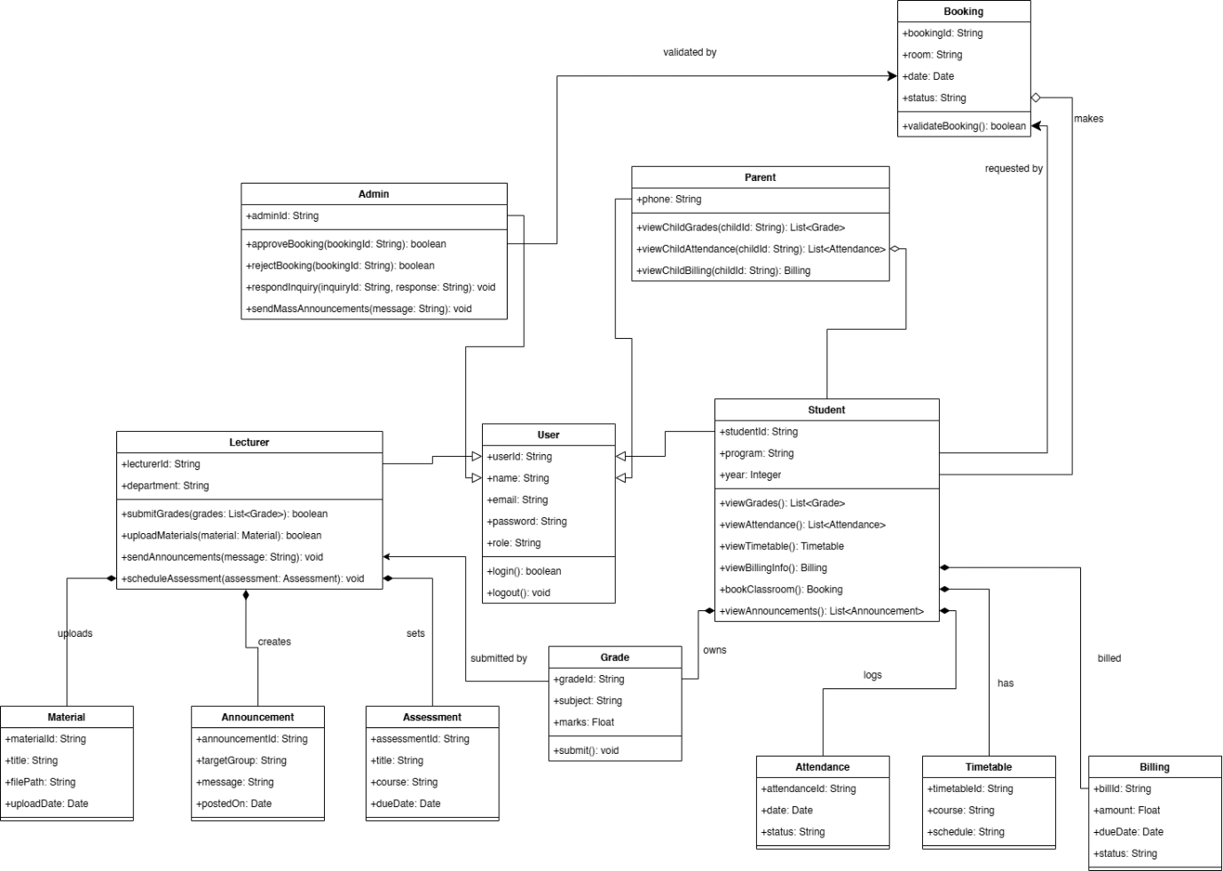

*Figure 3.6: Class Diagram*

The Class Diagram in Figure 3.6 illustrates the static structure of the University Communication and Services Portal (myMMU), showing the system’s classes, their attributes, operations (methods), and the relationships among objects. This model reflects how different users such as Students, Parents, Lecturers, and Admins interact with various components within the platform.

The central class is User, which serves as a generalization for specific roles like Student, Parent, Lecturer, and Admin. Each user type has distinct functionalities defined in their respective classes. The Student class, for example, provides methods to view grades, attendance, timetables, billing info, book classrooms, and view announcements. The Parent class allows access to a child's academic and billing information, while Lecturers can upload materials, submit grades, send announcements, and schedule assessments. Admins are responsible for approving bookings, managing inquiries, and sending mass announcements.

Supporting classes include Booking, Grade, Attendance, Timetable, Billing, Material, Announcement, and Assessment. These classes represent the core data entities manipulated by user roles. Relationships between these classes are modeled using associations such as “owns,” “uploads,” “raises,” and “monitors,” indicating how information flows and how entities interact within the system. The subsections below will describe each model and their data attributes. It will detail how the data will be stored inside the database as well as the description of each data attribute.

### 3.6.1 User Class

*Table 3.6.1: User Data Dictionary*

|  |  |  |  |  |
| --- | --- | --- | --- | --- |
| **Field Name** | **Description** | **Data Type** | **Constraints** | **Extra Notes** |
| userID | Unique identifier of a user | UUID | Primary Key Not Null Unique |  |
| username | Username picked by user | String | Not Null Unique | Login Credentials |
| password | User account password | String | Not Null | Login Credentials |
| name | Full name of the user | String | Not Null |  |
| email | Email address | String | Not Null |  |
| blockedUsers | List of blocked users | Array<User> |  |  |
| followedUsers | List of followed users | Array<User> |  |  |
| linkedSocMed | Linked social media accounts | Array<SocialMedia> |  |  |
| privateChat | Conversation history | Hashmap<User, Array<String>> |  |  |

### 3.6.2 Student Class

*Table 3.6.2: Student Data Dictionary*

|  |  |  |  |  |
| --- | --- | --- | --- | --- |
| **Field Name** | **Description** | **Data Type** | **Constraints** | **Extra Notes** |
| studentId | Student unique ID | String | Primary Key Not Null |  |
| program | Program enrolled | String | Not Null |  |
| year | Year of study | Integer | Not Null |  |

### 3.6.3 Lecturer Class

*Table 3.6.3: Lecturer Data Dictionary*

|  |  |  |  |  |
| --- | --- | --- | --- | --- |
| **Field Name** | **Description** | **Data Type** | **Constraints** | **Extra Notes** |
| lecturerId | Lecturer ID | String | Primary Key Not Null |  |
| department | Department name | String | Not Null |  |

### 3.6.4 Parent Class

*Table 3.6.4: Parent Data Dictionary*

|  |  |  |  |  |
| --- | --- | --- | --- | --- |
| **Field Name** | **Description** | **Data Type** | **Constraints** | **Extra Notes** |
| phone | Parent's contact number | String | Not Null |  |

### 3.6.5 Admin Class

*Table 3.6.5: Admin Data Dictionary*

|  |  |  |  |  |
| --- | --- | --- | --- | --- |
| **Field Name** | **Description** | **Data Type** | **Constraints** | **Extra Notes** |
| adminId | Admin ID | String | Primary Key Not Null |  |
| office | Office location | String |  |  |

### 3.6.6 Booking Class

*Table 3.6.6: Booking Data Dictionary*

|  |  |  |  |  |
| --- | --- | --- | --- | --- |
| **Field Name** | **Description** | **Data Type** | **Constraints** | **Extra Notes** |
| bookingId | Booking ID | String | Primary Key |  |
| room | Room number/name | String | Not Null |  |
| date | Booking date | Date | Not Null |  |
| status | Booking status | String | Pending/Approved/Rejected |  |

### 3.6.7 Grade Class

*Table 3.6.7: Grade Data Dictionary*

|  |  |  |  |  |
| --- | --- | --- | --- | --- |
| **Field Name** | **Description** | **Data Type** | **Constraints** | **Extra Notes** |
| gradeId | Grade record ID | String | Primary Key |  |
| studentId | Student who received grade | String | Foreign Key |  |
| subject | Subject name | String |  |  |
| marks | Score received | Float |  |  |

### 3.6.8 Billing Class

*Table 3.6.8: Billing Data Dictionary*

|  |  |  |  |  |
| --- | --- | --- | --- | --- |
| **Field Name** | **Description** | **Data Type** | **Constraints** | **Extra Notes** |
| billId | Billing ID | String | Primary Key |  |
| studentId | Student responsible | String | Foreign Key |  |
| amount | Bill amount | Float |  |  |
| dueDate | Due date | Date |  |  |
| status | Paid or Unpaid | String |  |  |

### 3.6.9 Attendance Class

*Table 3.6.9: Attendance Data Dictionary*

|  |  |  |  |  |
| --- | --- | --- | --- | --- |
| **Field Name** | **Description** | **Data Type** | **Constraints** | **Extra Notes** |
| attendanceId | Attendance record ID | String | Primary Key |  |
| studentId | Student who attended | String | Foreign Key |  |
| date | Attendance date | Date |  |  |
| status | Present/Absent | String |  |  |

### 3.6.10 Material Class

*Table 3.6.10: Material Data Dictionary*

|  |  |  |  |  |
| --- | --- | --- | --- | --- |
| **Field Name** | **Description** | **Data Type** | **Constraints** | **Extra Notes** |
| materialId | Material ID | String | Primary Key |  |
| lecturerId | Uploader's ID | String | Foreign Key |  |
| title | Material title | String | Not Null |  |
| filePath | Storage path or URL | String |  |  |
| uploadDate | Date uploaded | Date |  |  |

### 3.6.11 Announcement Class

*Table 3.6.11: Announcement Data Dictionary*

|  |  |  |  |  |
| --- | --- | --- | --- | --- |
| **Field Name** | **Description** | **Data Type** | **Constraints** | **Extra Notes** |
| announcementId | Announcement ID | String | Primary Key |  |
| senderId | Sender user ID | String | Foreign Key |  |
| targetGroup | Target audience | String |  | e.g., student, parent, lecturer |
| message | Message content | String | Not Null |  |
| postedOn | Post date | Date |  |  |

### 3.6.12 Timetable Class

*Table 3.6.12: Timetable Data Dictionary*

|  |  |  |  |  |
| --- | --- | --- | --- | --- |
| **Field Name** | **Description** | **Data Type** | **Constraints** | **Extra Notes** |
| timetableId | Timetable ID | String | Primary Key |  |
| studentId | Linked student | String | Foreign Key |  |
| course | Course name | String |  |  |
| schedule | Class time info | String |  |  |

### 3.6.13 Assessment Class

*Table 3.6.13: Assessment Class*

|  |  |  |  |  |
| --- | --- | --- | --- | --- |
| **Field Name** | **Description** | **Data Type** | **Constraints** | **Extra Notes** |
| assessmentId | Assessment ID | String | Primary Key |  |
| lecturerId | Lecturer responsible | String | Foreign Key |  |
| title | Assessment title | String | Not Null |  |
| course | Associated course | String |  |  |
| dueDate | Submission deadline | Date |  |  |

# 3.7 Design Constraints

This section outlines the design constraints and limitations that must be taken into account throughout the development of the system. These constraints may stem from legal, technical, organizational, and usability factors. They help ensure that the system aligns with regulatory compliance, organizational policies, and platform compatibility standards. The table below presents the key design constraints applicable to the system.

Table 3.7: Design constraints table

|  |  |  |  |
| --- | --- | --- | --- |
| **Requirement ID** | **Description** | **Priority** | **Author** |
| REQ_DC001 | The system shall comply with the Web Content Accessibility Guidelines (WCAG) to ensure usability for users with disabilities. | Medium | [Your Name Here] |
| REQ_DC002 | The system shall process personal data in compliance with the Personal Data Protection Act (PDPA) and applicable regulations. | High | [Your Name Here] |
| REQ_DC003 | The system shall be developed and deployed within a 2-year timeframe to meet academic cycle planning. | High | [Your Name Here] |
| REQ_DC004 | The system shall not contain any advertisements or third-party marketing content. | High | [Your Name Here] |
| REQ_DC005 | The platform shall use secure and approved libraries and frameworks to reduce security risks. | Medium | [Your Name Here] |
| REQ_DC006 | The system shall be compatible with commonly used web browsers (e.g., Chrome, Firefox, Edge, Safari) and mobile platforms. | High | [Your Name Here] |
| REQ_DC007 | The system shall be optimized for both desktop and mobile use, ensuring consistent user experience. | High | [Your Name Here] |
| REQ_DC008 | The platform shall integrate with the existing university Campus Management System and SMS Gateway without major infrastructure changes. | High | [Your Name Here] |
| REQ_DC009 | The platform shall align with the university's branding, including logo usage, color schemes, and tone of communication. | Medium | [Your Name Here] |
| REQ_DC010 | The system shall be designed with modularity to support future scalability, feature expansion, and integration. | High | [Your Name Here] |
| REQ_DC011 | The system shall implement encryption techniques compliant with university IT security standards to protect sensitive data. | High | [Your Name Here] |
| REQ_DC012 | The system shall follow low energy consumption standards to minimize environmental impact of 24/7 hosting. | Low | [Your Name Here] |

# 3.8 Standard Compliance

This section outlines the standard compliance requirements considered during the development of the myMMU University Communication and Services Portal. These requirements ensure that the system aligns with relevant regulations, promotes secure data handling, enhances accessibility for all users, and ensures system interoperability and quality.

*Table 3.8: Standard Compliance Table*

|  |  |  |  |
| --- | --- | --- | --- |
| **Requirement ID** | **Description** | **Priority** | **Author** |
| REQ_SC001 | The system shall comply with the Personal Data Protection Act (PDPA) to ensure secure handling of students’, parents’, and staff’s personal and academic data. | High | Yang Jia En |
| REQ_SC002 | The platform shall adhere to the Web Content Accessibility Guidelines (WCAG) 2.1, ensuring the system is accessible to users with disabilities, including support for screen readers and high-contrast modes. | High | Yang Jia En |
| REQ_SC003 | The platform shall follow the ISO/IEC 27001 standard to implement and maintain effective information security controls. | High | Yang Jia En |
| REQ_SC004 | The system shall align with the ISO/IEC 25010 quality model to ensure proper focus on functionality, reliability, usability, and maintainability. | Medium | Yang Jia En |
| REQ_SC005 | The system shall comply with the Digital Millennium Copyright Act (DMCA) or equivalent institutional copyright policies to avoid infringement of uploaded educational content. | Medium | Yang Jia En |

## 3.9 Software System Attributes

This section describes the essential qualities and characteristics the University Communication and Services Portal must fulfill. These software attributes define how the system should behave in terms of performance, reliability, maintainability, and user interaction, ensuring the system functions smoothly and supports its users effectively.

### 3.9.1 Accuracy

|  |  |  |  |
| --- | --- | --- | --- |
| **Requirement ID** | **Description** | **Priority** | **Author** |
| REQ_SRA001 | The system shall maintain an error rate below 0.001% in all academic calculations and data displays (e.g., grade averages, billing summaries). | High | [Your Name Here] |

### 3.9.2 Availability

|  |  |  |  |
| --- | --- | --- | --- |
| **Requirement ID** | **Description** | **Priority** | **Author** |
| REQ_SRA002 | The system shall ensure at least 99.9% uptime with a maximum downtime of 8 hours annually, excluding scheduled maintenance. | High | [Your Name Here] |

### 3.9.3 Reliability

|  |  |  |  |
| --- | --- | --- | --- |
| **Requirement ID** | **Description** | **Priority** | **Author** |
| REQ_SRA003 | The system shall handle large volumes of student logins and data access requests without crashing. | High | [Your Name Here] |

### 3.9.4 Security

|  |  |  |  |
| --- | --- | --- | --- |
| **Requirement ID** | **Description** | **Priority** | **Author** |
| REQ_SRA006 | All user data shall be protected from unauthorized access through secure storage and retrieval mechanisms. | High | [Your Name Here] |
| REQ_SRA007 | The system shall implement secure login, role-based access control, and encrypted data transmission. | High | [Your Name Here] |
| REQ_SRA008 | The server APIs shall authenticate requests and verify session integrity. | High | [Your Name Here] |
| REQ_SRA009 | The system shall enforce strong password policies including complexity and expiration. | High | [Your Name Here] |
| REQ_SRA010 | The system shall undergo regular penetration testing and vulnerability assessments. | Medium | [Your Name Here] |
| REQ_SRA011 | The system shall include a firewall and monitoring system to protect against external threats. | High | [Your Name Here] |
| REQ_SRA012 | The system shall support multi-factor authentication for enhanced security. | High | [Your Name Here] |
| REQ_SRA013 | The system shall apply data masking in staging environments to protect sensitive records. | Medium | [Your Name Here] |

### 3.9.5 Maintainability

|  |  |  |  |
| --- | --- | --- | --- |
| **Requirement ID** | **Description** | **Priority** | **Author** |
| REQ_SRA014 | The system’s codebase shall be well-documented to support efficient updates and troubleshooting. | High | [Your Name Here] |
| REQ_SRA015 | The system shall use version control to track changes and ensure collaborative updates. | High | [Your Name Here] |
| REQ_SRA016 | The system shall be developed using modular and agile principles. | High | [Your Name Here] |
| REQ_SRA017 | The code shall maintain low coupling and high cohesion to simplify testing and maintenance. | High | [Your Name Here] |
| REQ_SRA018 | The system shall provide logs for user activity and errors to assist with diagnostics. | High | [Your Name Here] |
| REQ_SRA019 | The platform shall offer manuals and help documents for staff and IT administrators. | Medium | [Your Name Here] |
| REQ_SRA020 | The system shall have a backup and disaster recovery mechanism with quarterly drills. | High | [Your Name Here] |
| REQ_SRA021 | The system shall support future upgrades without affecting existing services. | High | [Your Name Here] |
| REQ_SRA022 | The system shall be backward compatible with previous releases for a minimum of one academic year. | Medium | [Your Name Here] |
| REQ_SRA023 | A support channel shall be available for users to report technical issues and receive help. | High | [Your Name Here] |

### 3.9.6 Portability

|  |  |  |  |
| --- | --- | --- | --- |
| **Requirement ID** | **Description** | **Priority** | **Author** |
| REQ_SRA024 | The system shall support access on major operating systems (Windows, macOS, Linux, Android, iOS). | High | [Your Name Here] |
| REQ_SRA025 | The system shall function correctly on standard web browsers including Chrome, Firefox, Safari, and Edge. | High | [Your Name Here] |

### 3.9.7 Usability

|  |  |  |  |
| --- | --- | --- | --- |
| **Requirement ID** | **Description** | **Priority** | **Author** |
| REQ_SRA026 | The system shall maintain a consistent UI layout, theme, and interaction style. | High | [Your Name Here] |
| REQ_SRA027 | The system interface shall be intuitive, easy to navigate, and understandable for all user groups. | High | [Your Name Here] |

# 

# **3.10 Supporting Information**

Throughout the elicitation phase, five elicitation methods were used to understand the users’ needs and requirements towards the development of myMMU.

### 3.10.1 Brainstorming

An initial brainstorming session involving all team members was conducted to hypothesize user needs and pain points with the current system. The session identified core stakeholder groups and proposed feature ideas including:

* Role-based portal views (student, lecturer, parent, admin)
* SMS notifications for billing and attendance alerts
* A classroom booking module with admin approval
* A user-friendly dashboard and accessibility enhancements

The ideas generated during this phase informed the direction of subsequent elicitation techniques and prototype designs.

### 3.10.2 Questionnaire

A structured questionnaire comprising over 30 questions was disseminated to stakeholders through Google Forms over a span of five days. More than 25 responses were collected from diverse user roles, including students, lecturers, parents, and admins. The questionnaire incorporated Likert-scale, multiple-choice, and open-ended questions, and utilized Kano-style paired questions to help classify features as dissatisfiers, satisfiers, or delighters.

Key Findings:

* Students expressed strong interest in real-time access to academic records, attendance, and billing information.
* Parents emphasized the value of SMS notifications for academic alerts and fee reminders.
* Lecturers prioritized ease in uploading materials and scheduling assessments.
* Users across all roles suggested improvements in login experience, such as a "Remember Me" option.

Below are the results and demographic for the questionnaire.

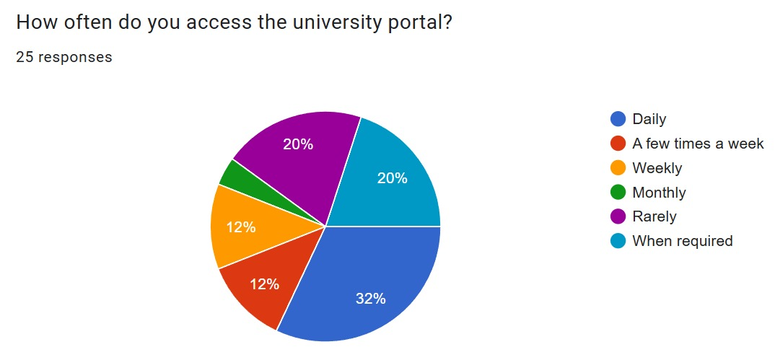

Figure 3.10.2.1: Questionnaire Response 1

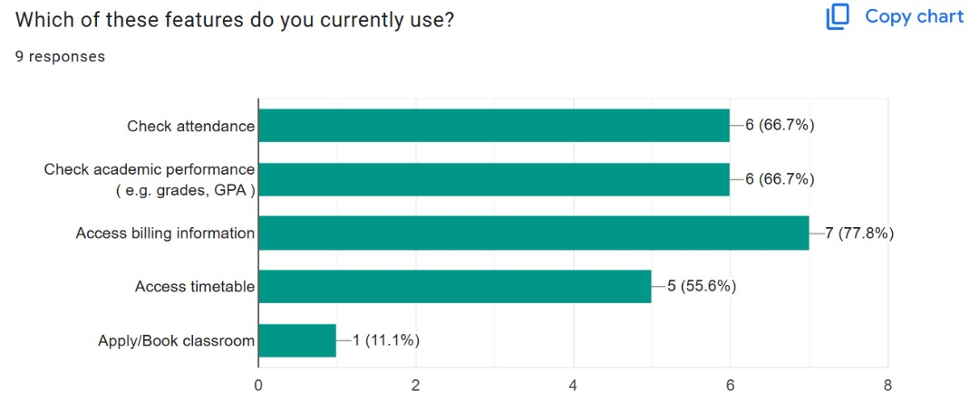

Figure 3.10.2.2: Questionnaire Response 2

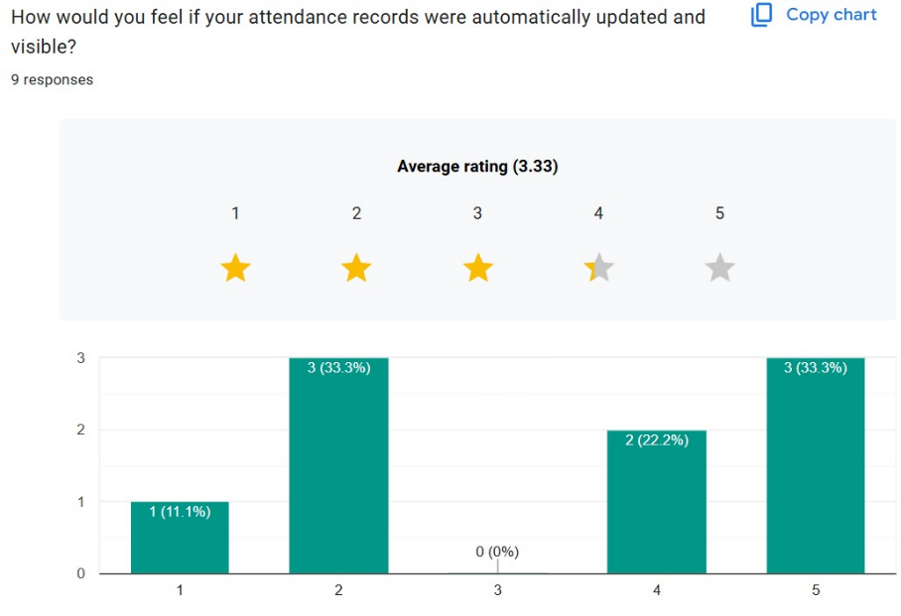

Figure 3.10.2.3: Questionnaire Response 3

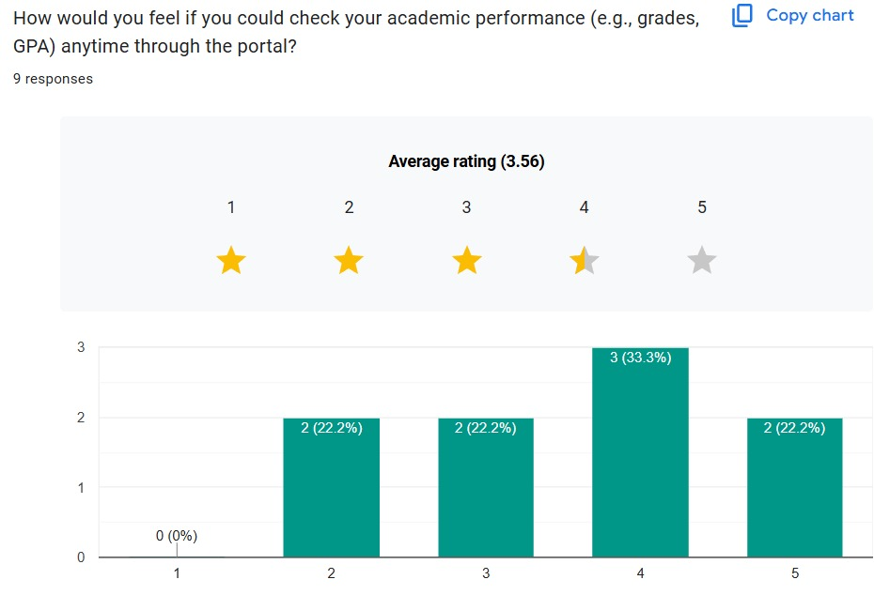

Figure 3.10.2.4: Questionnaire Response 4

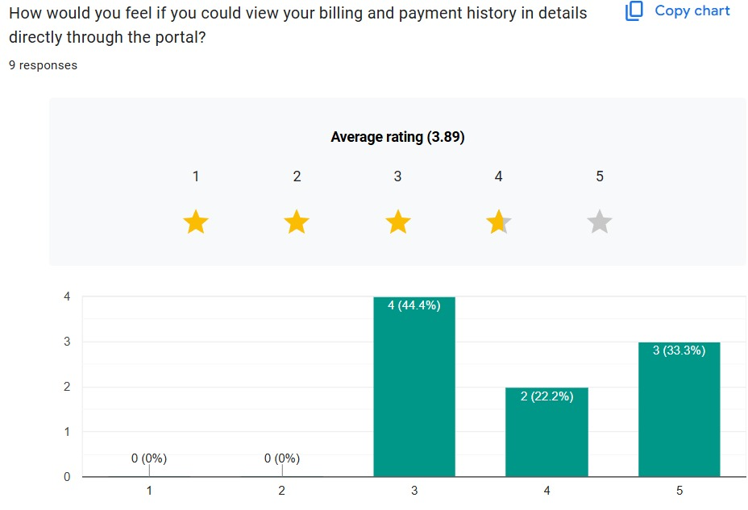

Figure 3.10.2.5: Questionnaire Response 5

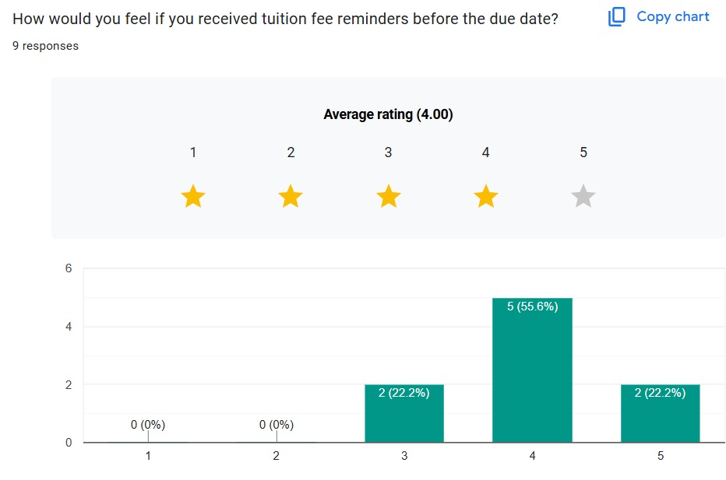

Figure 3.10.2.6: Questionnaire Response 6

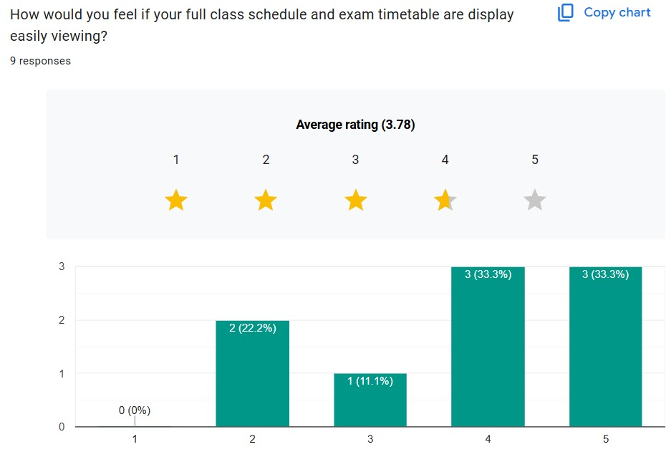

Figure 3.10.2.7: Questionnaire Response 7

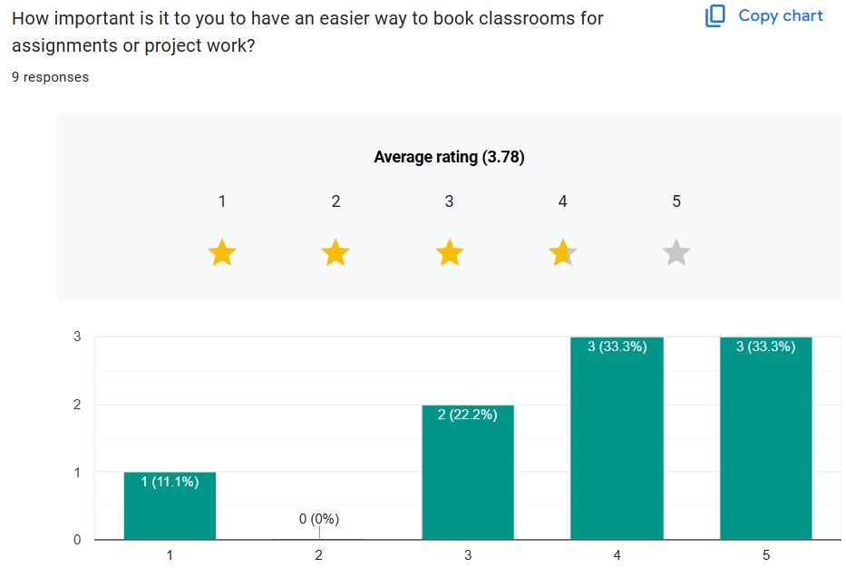

Figure 3.10.2.8: Questionnaire Response 8

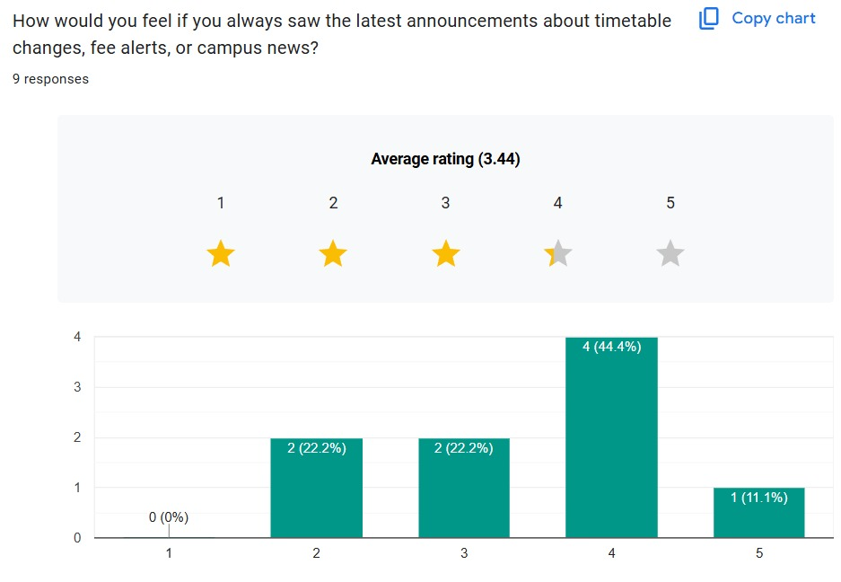

Figure 3.10.2.9: Questionnaire Response 9

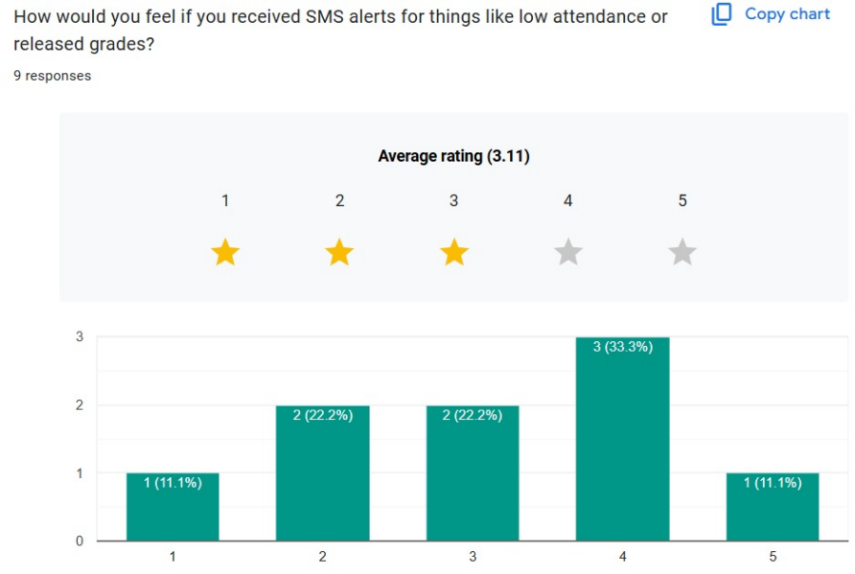

Figure 3.10.2.10: Questionnaire Response 10

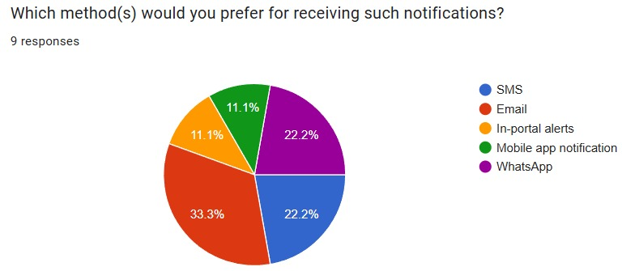

Figure 3.10.2.11: Questionnaire Response 11

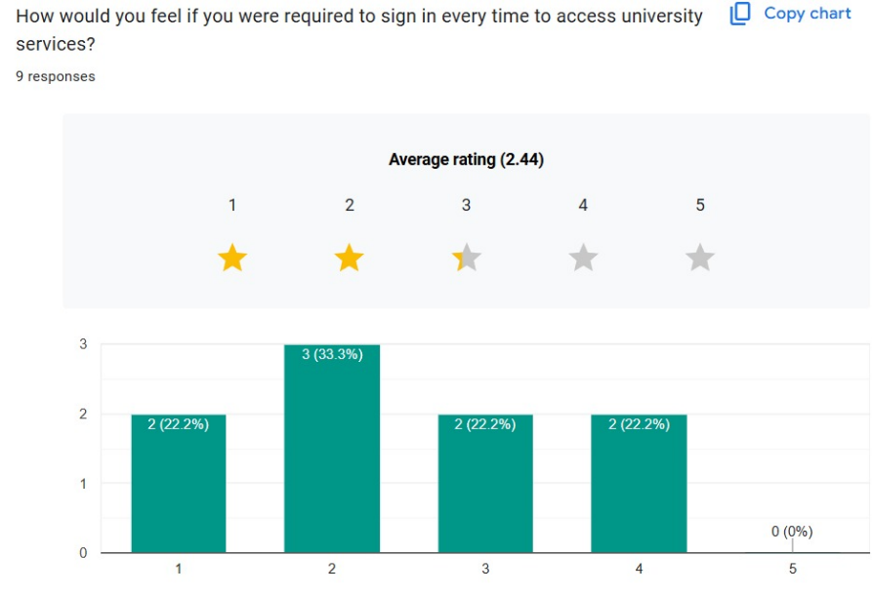

Figure 3.10.2.12: Questionnaire Response 12

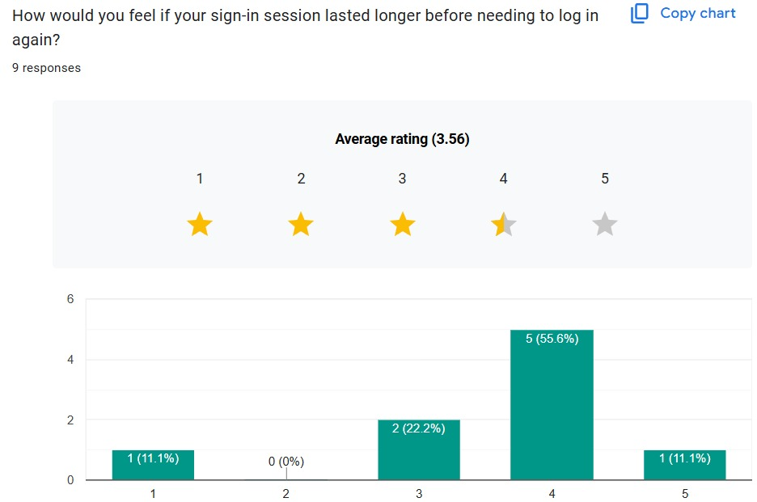

Figure 3.10.2.13: Questionnaire Response 13

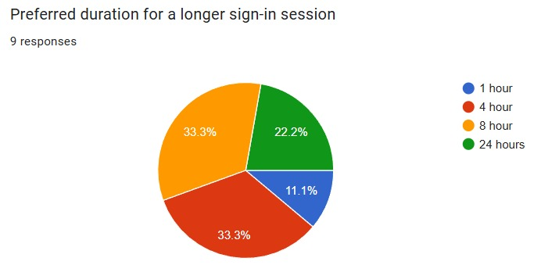

Figure 3.10.2.14: Questionnaire Response 14

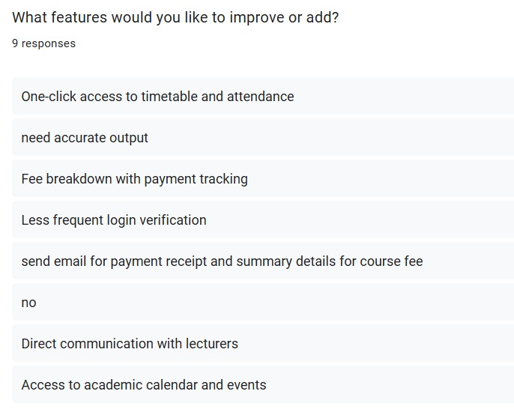

Figure 3.10.2.15: Questionnaire Response 15

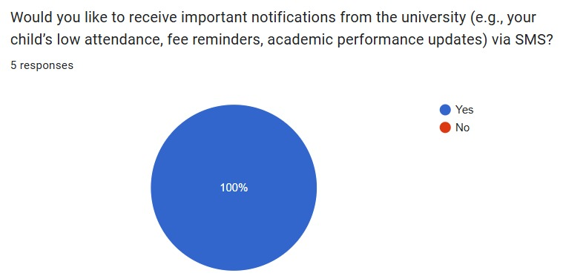

Figure 3.10.2.16: Questionnaire Response 16

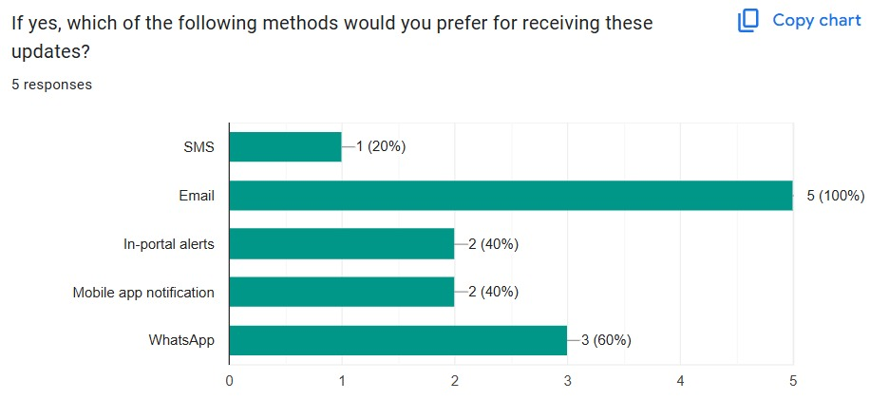

Figure 3.10.2.17: Questionnaire Response 17

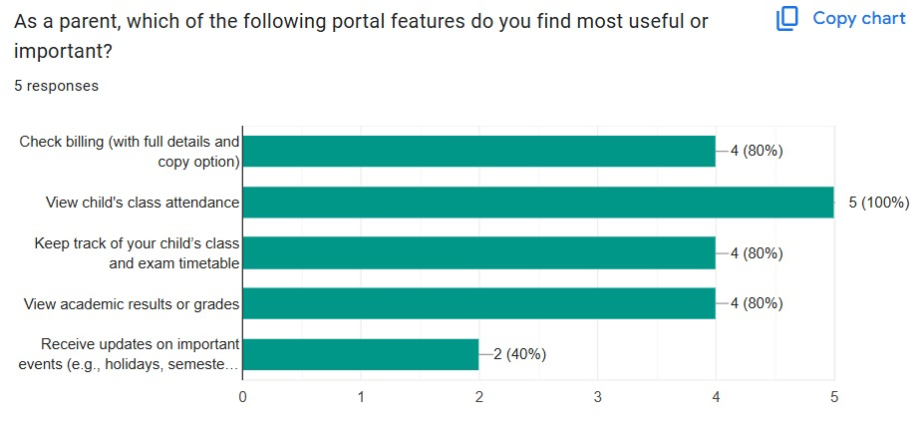

Figure 3.10.2.18: Questionnaire Response 18

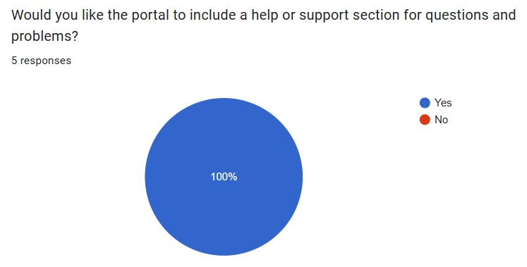

Figure 3.10.2.19: Questionnaire Response 19

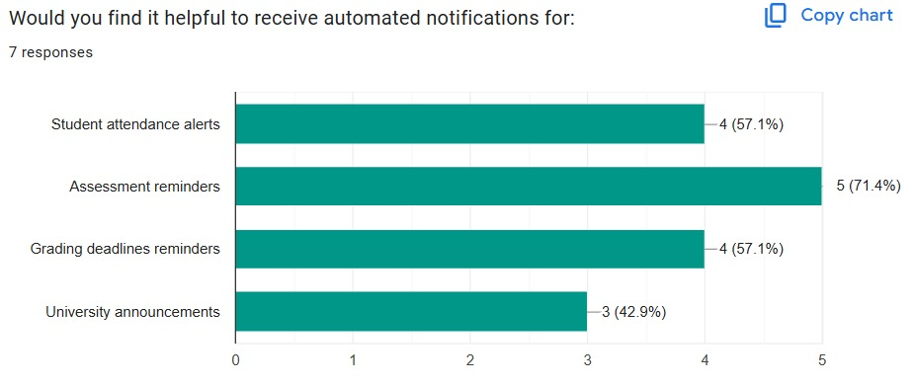

Figure 3.10.2.20: Questionnaire Response 20

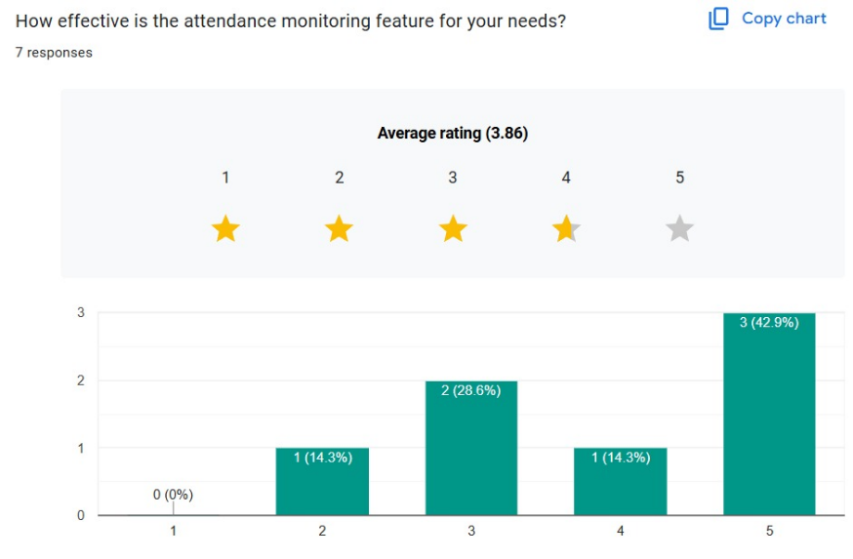

Figure 3.10.2.21: Questionnaire Response 21

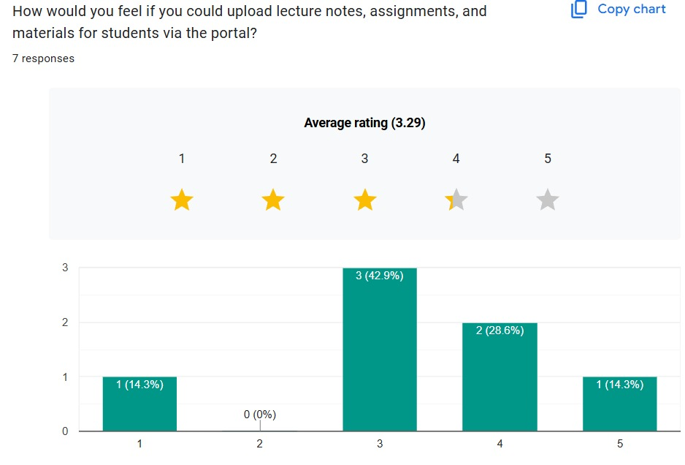

Figure 3.10.2.22: Questionnaire Response 22

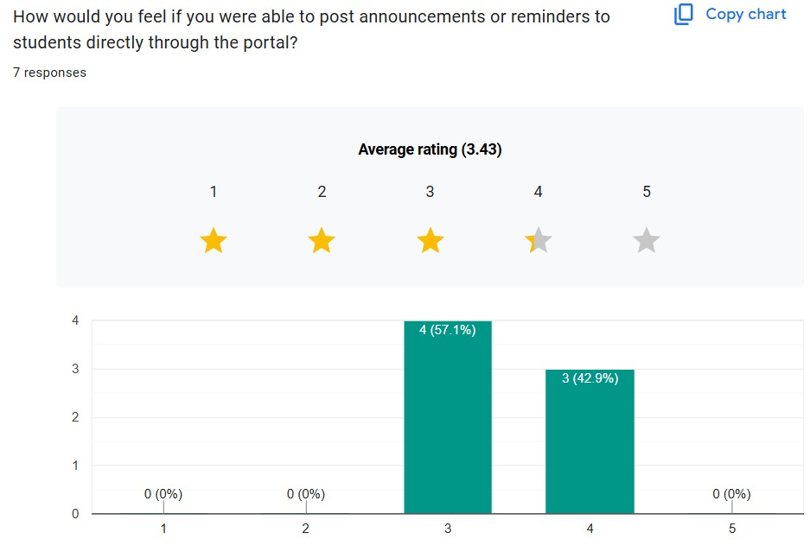

Figure 3.10.2.23: Questionnaire Response 23

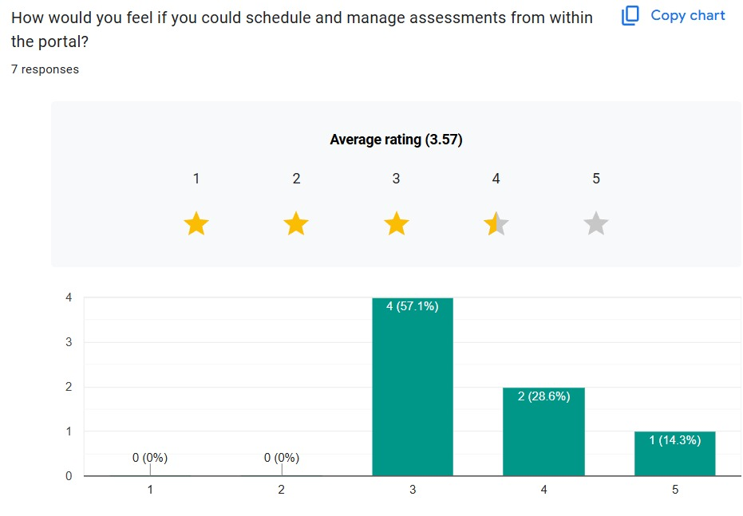

Figure 3.10.2.24: Questionnaire Response 24

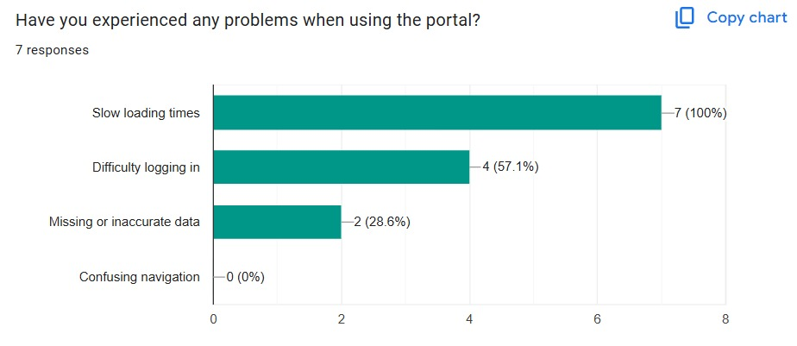

Figure 3.10.2.25: Questionnaire Response 25

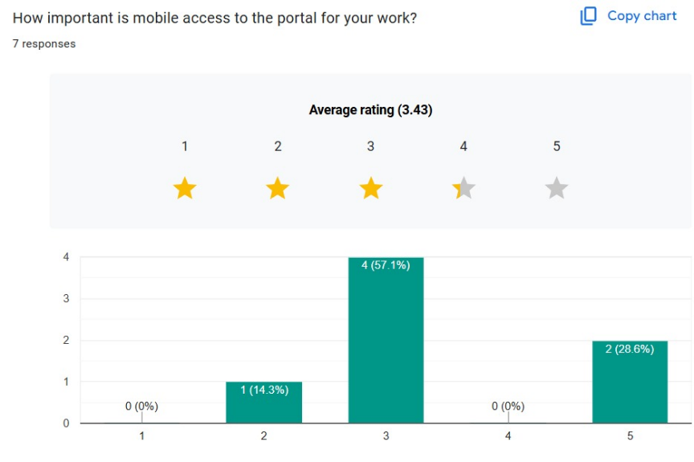

Figure 3.10.2.26: Questionnaire Response 26

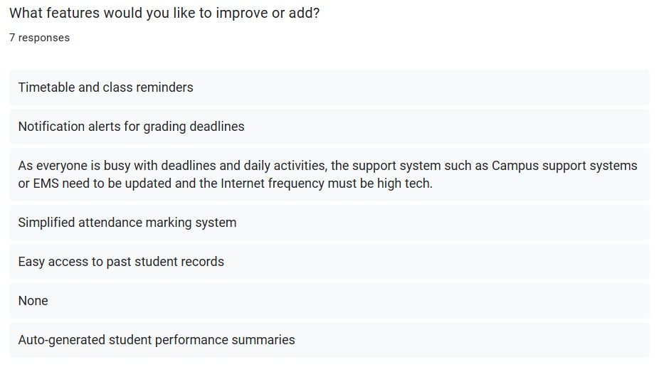

Figure 3.10.2.27: Questionnaire Response 27

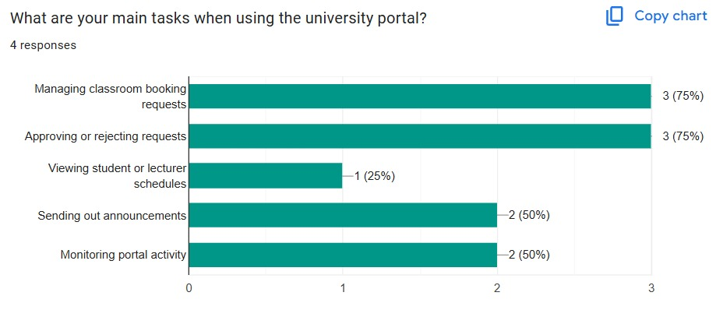

Figure 3.10.2.28: Questionnaire Response 28

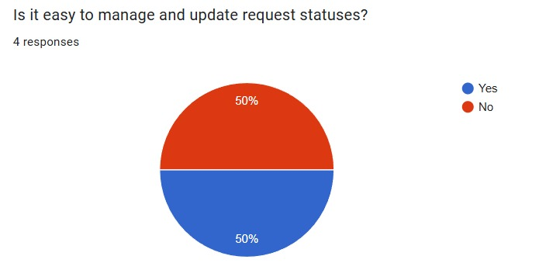

Figure 3.10.2.29: Questionnaire Response 29

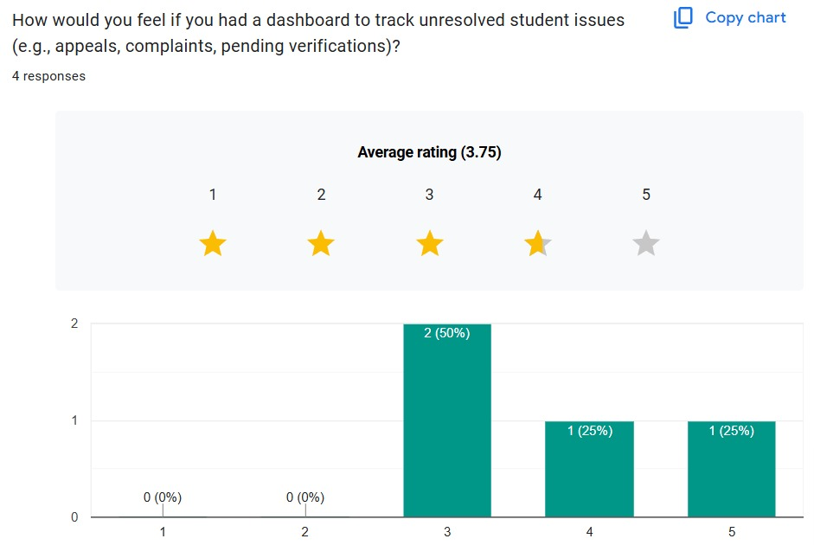

Figure 3.10.2.30: Questionnaire Response 30

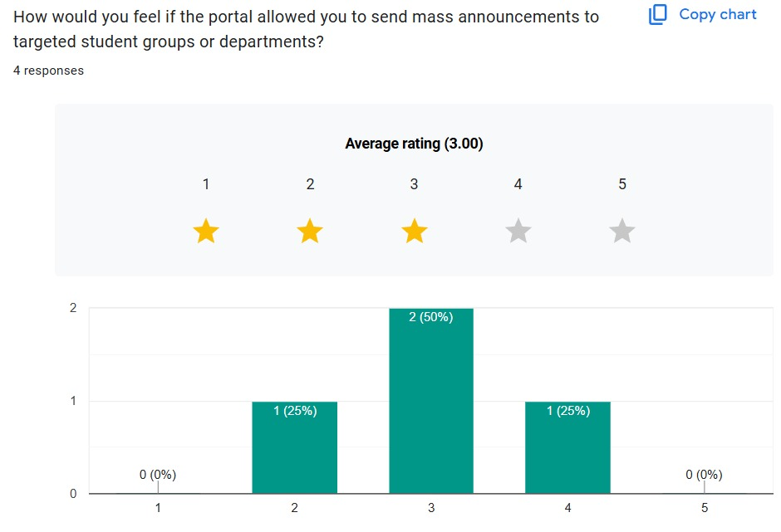

Figure 3.10.2.31: Questionnaire Response 31

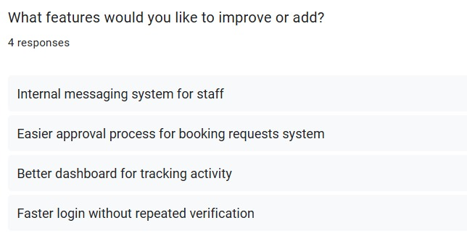

Figure 3.10.2.32: Questionnaire Response 32

### 3.10.3 Interview

To collect in-depth qualitative feedback, a brief one-on-one interview was held with a student stakeholder. The purpose was to explore everyday interactions with the current university portal, identify functional challenges, and assess interest in potential new features using a Kano-style inquiry.

Interview Details:

* Participant: 1 student (Participant 01)
* Role: Regular portal user
* Duration: Approximately 5 minutes
* Method: Audio recording (camera declined for privacy)

Key Insights:

* The student primarily uses the portal for accessing billing information, academic records, timetables, and university announcements.
* Common frustrations include the repetitive OTP verification process and slow system responsiveness during login.

Suggested Improvements:

* Include a "Remember Me" option to streamline the login experience.
* Provide confirmation emails upon successful tuition or fee payments.

Features the Student Appreciated Most:

* A centralized dashboard combining attendance, grades, and billing in one place.
* SMS notifications for important updates such as approaching deadlines or released results.
* A clear and well-organized timetable interface for classes and exams.

Unexpected but Welcomed Idea (Delighter):

* Introducing the option to purchase MMU parking stickers online to avoid physically queuing at university offices.

Link to the interview:

<https://drive.google.com/file/d/11id5Mvk2kyyic8F7EqLziCZ_IXjenjQ3/view?usp=sharing>

### 3.10.4 Prototyping

To validate the usability and layout of the University Communication and Services Portal, a set of low-fidelity prototypes was created targeting the student user role. The goal was to visualize key interfaces, test navigation flow, and gather preliminary feedback on feature accessibility and clarity before development.

The prototypes were designed using Figma and focused on core pages that reflect the main use cases for students.

Pages Developed:

* Login Page – Secure sign-in interface with fields for MMU credentials
* Dashboard Page – Centralized summary of announcements, grades, timetable, and quick links
* View Grades Page – Tabular format of course results with GPA summary
* View Attendance Page – Attendance breakdown by course with absence alerts
* View Timetable Page – Weekly calendar view with filters for class and exam schedules
* View Billing Info Page – Overview of payment history, upcoming dues, and receipt downloads
* Book Classroom Page – Booking form with date/time picker and facility options
* View Announcements Page – Feed of campus-wide notices and academic updates

Activity details:

* Platform: Figma
* Duration: 3 days of design iterations
* Reviewers: Internal project team and two student testers
* Feedback method: Verbal walkthrough and comment pins in Figma

Key Feedback Highlights:

* Navigation was intuitive; testers liked the clean layout and role-based flow
* Suggested adding filters for announcements (e.g., urgent, academic, billing)
* Recommended that booking confirmation appears immediately after submission
* Interest in a color-coded timetable to separate lectures and assessments

Below are the screenshots of all Figma pages.

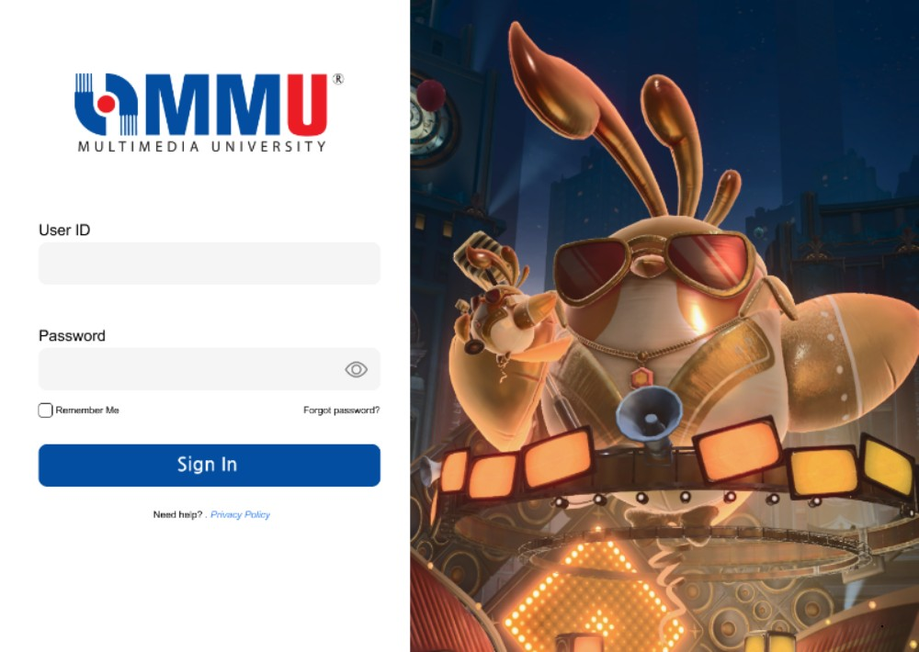

*Figure 3.10.4.1: User Log In Page*

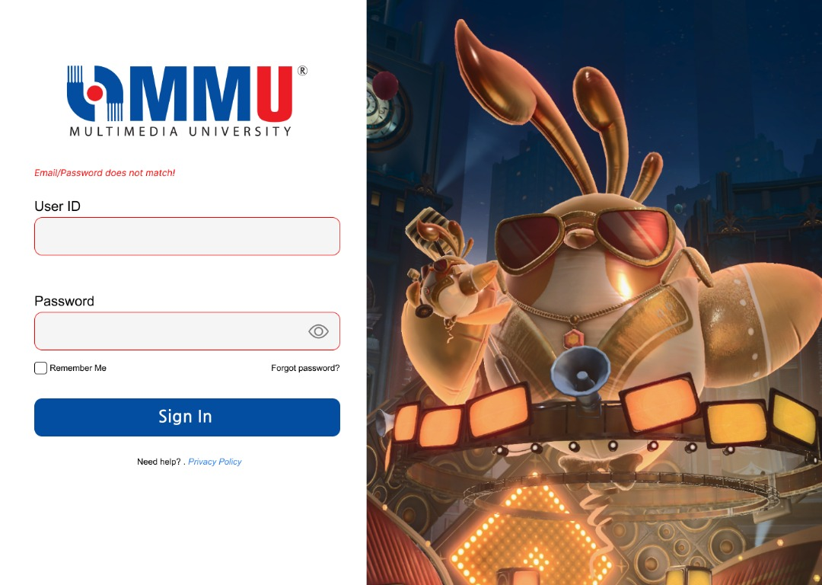

*Figure 3.10.4.2: User Log In Page with Error Message*

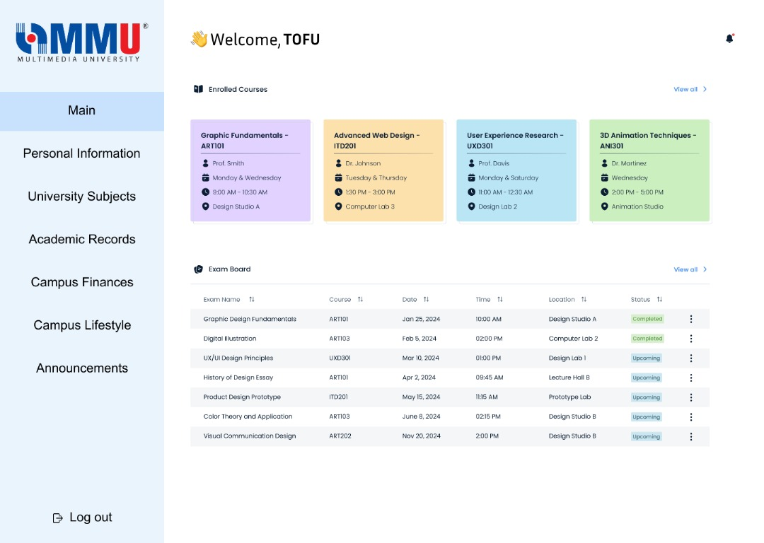

*Figure 3.10.4.3: Student Dashboard Page*

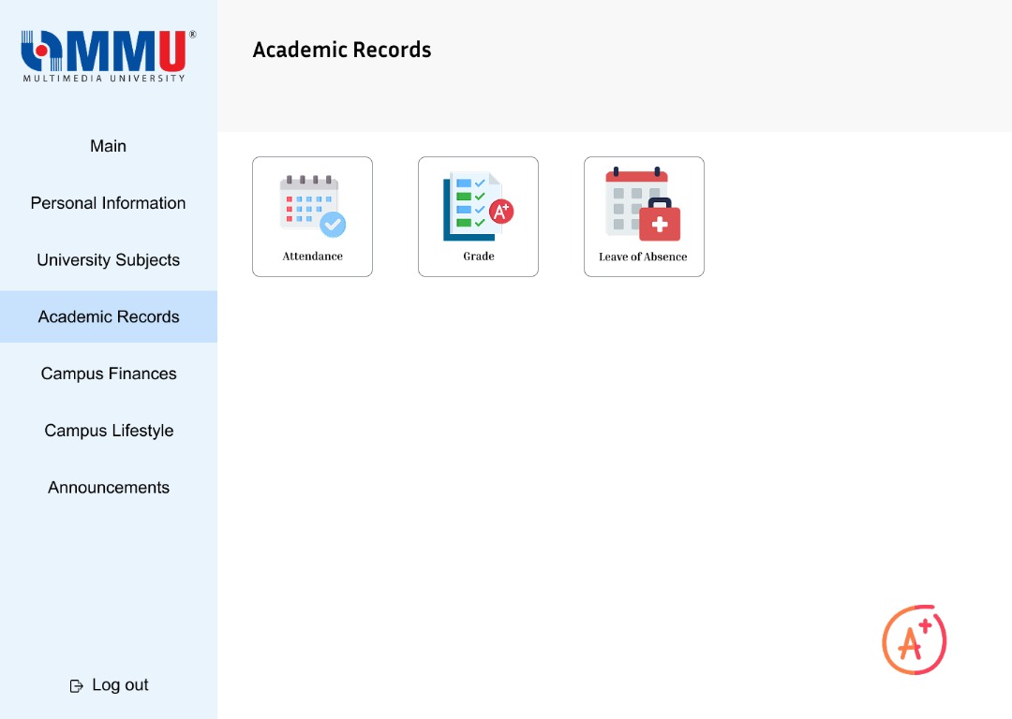

*Figure 3.10.4.4: Student View Academic Records Page*

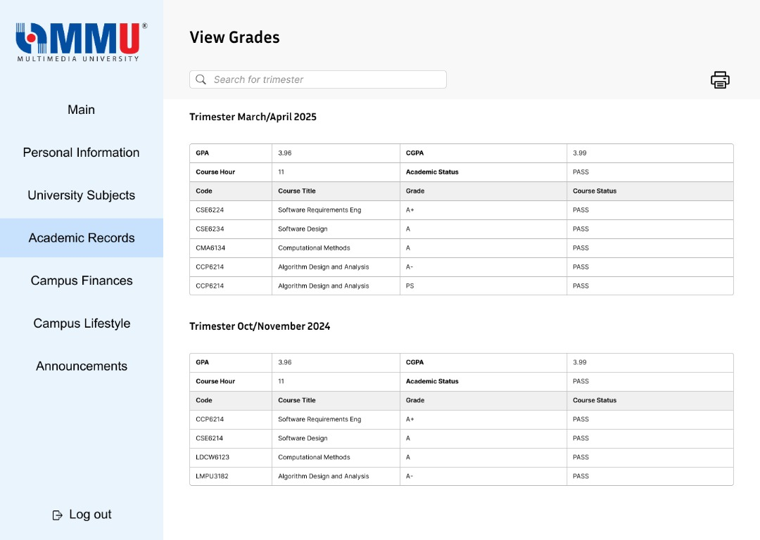

*Figure 3.10.4.5: Student View Grades Page*

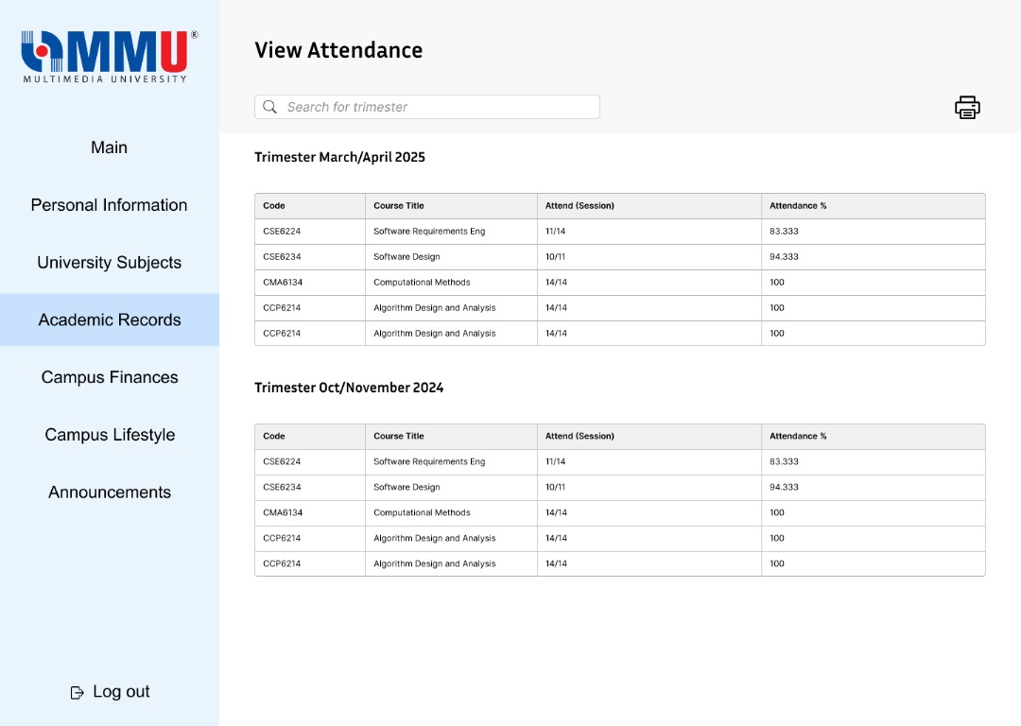

*Figure 3.10.4.6: Student View Attendance Page*

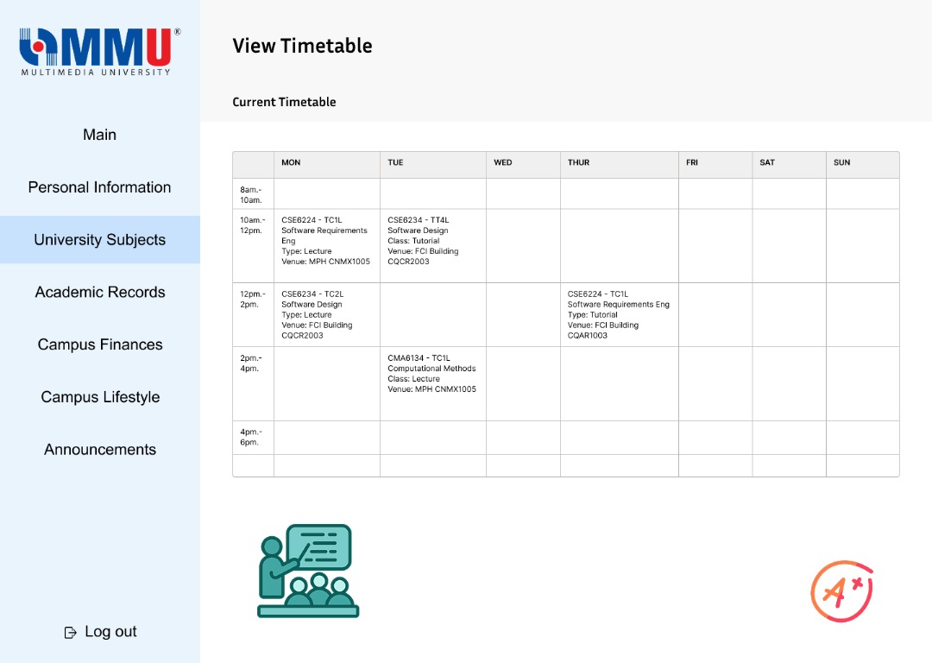

*Figure 3.10.4.7: Student View Attendance Page*

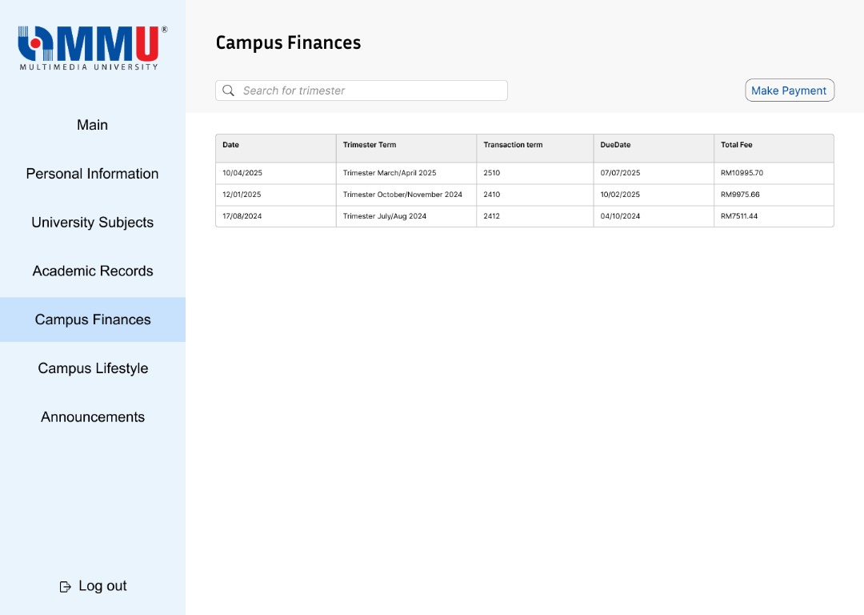

*Figure 3.10.4.8: Student View Billing Page 1*

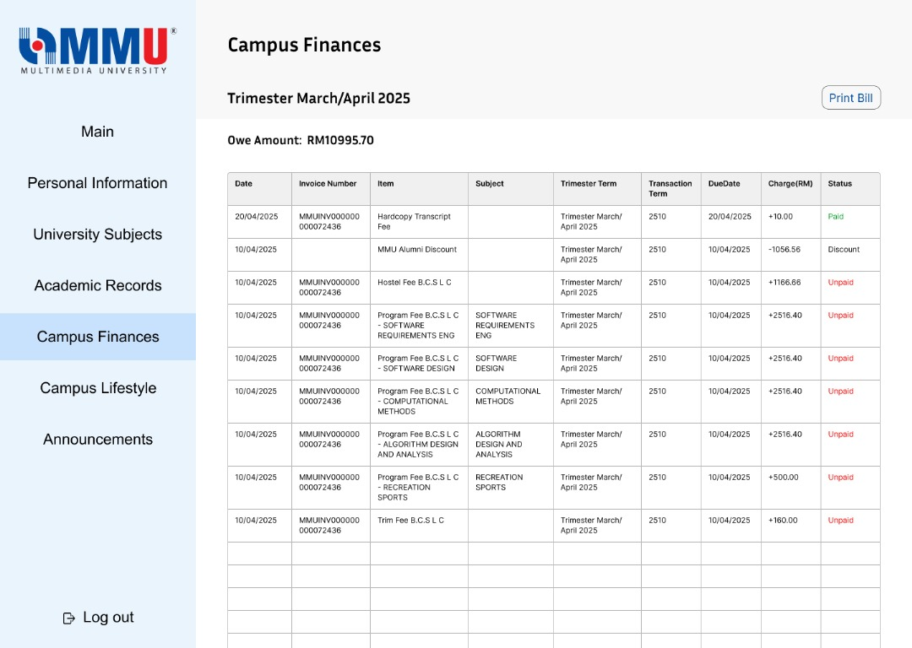

*Figure 3.10.4.9: Student View Billing Page 2*

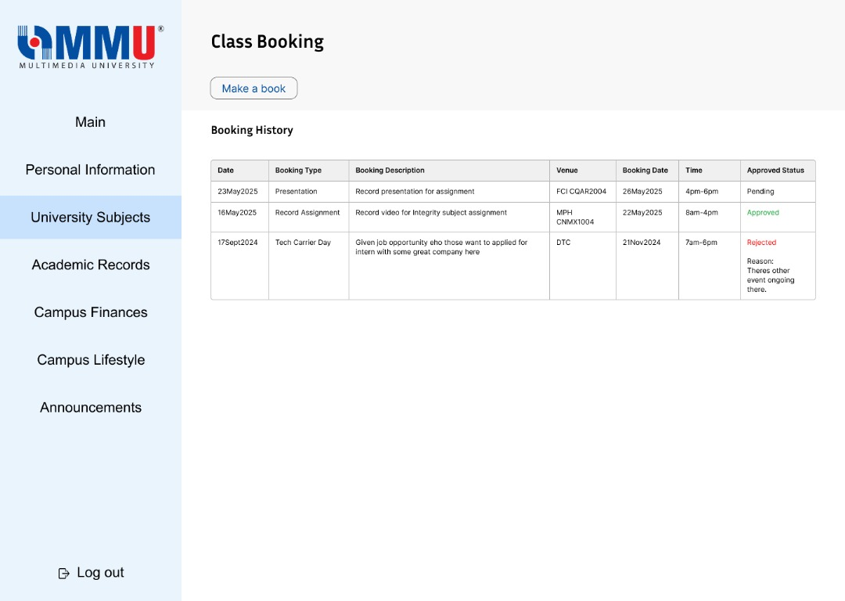

*Figure 3.10.4.10: Student Book Class Page*

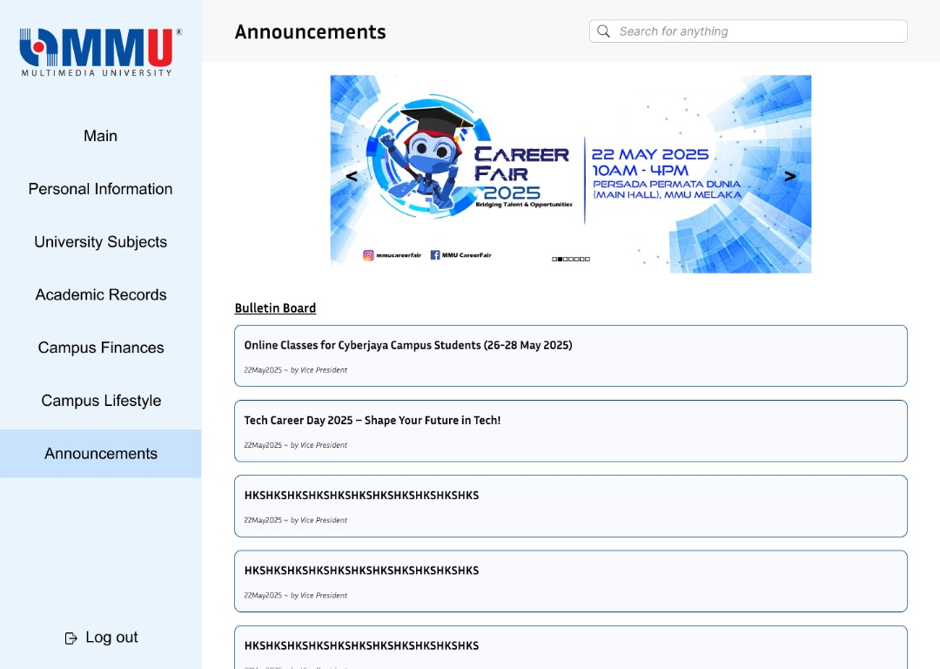

*Figure 3.10.4.11: Student Announcements Page*

### 3.10.5 Perspective-Based Reading

The table below outlines the features, feedback, and user-role-specific concerns derived from Perspective-Based Reading (PBR) conducted on early drafts of the myMMU University Communication and Services Portal. This technique involved internal reviewers role-playing as different stakeholder types — students, lecturers, parents, and admins — to evaluate draft requirements, mockups, and scenarios.

This process ensured that the system’s design aligns with each role’s expectations and highlights overlooked needs or inconsistencies. The findings were derived from multiple sources, including questionnaire results, interview feedback, and prototype reviews.

Table 3.10.5: Perspective-Based Reading Table

|  |  |  |
| --- | --- | --- |
| Features / Requests / Opinions | Description | Requirement ID |
| Extended Sign-In Session | Students requested longer login durations and a 'Remember Me' feature to reduce frequent re-authentication. | REQ_UCSP001 |
| SMS Notification Settings | Parents highlighted the need for configurable SMS alert preferences to avoid unwanted messages. | REQ_UCSP002 |
| Bulk Grade Upload | Lecturers suggested having an option to upload student grades in bulk and reuse previous announcement drafts. | REQ_UCSP003 |
| Booking Request Status Visibility | Admins identified the lack of status indicators for pending classroom bookings and requested a clearer interface for managing them. | REQ_UCSP004 |
| Dashboard Consolidation | Students expressed interest in a centralized dashboard combining attendance, grades, announcements, and billing information. | REQ_UCSP005 |
| Assessment Calendar Sync | Lecturers requested syncing assessment schedules with the existing timetable to avoid clashes and improve planning. | REQ_UCSP006 |
| Internal Communication System (Admin) | Admins proposed a built-in messaging system to respond to student inquiries directly within the portal. | REQ_UCSP007 |

# 4.0 Verification

## 4.1 Verification Approach

This section outlines how the system will be verified during development. It describes the testing methods, responsible team members, timeline, and environment used to ensure that the system meets its intended requirements.

How:

Functional testing, unit testing, and basic integration testing will be conducted to verify core features such as login, grade viewing, SMS alerts, and booking flows.

Who:

Verification will be carried out by the development team members themselves, using shared checklists and manual testing to validate system behavior.

When:

Testing will occur at the end of each completed module (e.g., after implementing login, attendance, etc.) and during integration week before submission.

Where:

All verification activities will be performed in a local development environment using test data, with simulated API connections where applicable.

## 4.2 Verification Criteria

The following criteria define how the software’s compliance with the specified functional and quality requirements will be verified:

Login response time must be less than 2 seconds under normal load.

The grade report download must complete within 5 seconds for a file size under 1MB.

SMS notifications must be triggered and sent within 1 second after the system event (e.g., low attendance alert).

Classroom booking confirmations must be reflected immediately after submission, with response time not exceeding 2 seconds.

The system shall maintain 99.9% uptime, excluding planned maintenance.

All submitted forms (e.g., fee payment confirmations, support inquiries) must display a success or failure message upon submission.

## 4.3 Requirement Verification

In this section, we outline the planned verification approaches and methods for validating the software functionality of myMMU. The verification process is aligned with key development milestones and includes details on the method used, responsible team members, timing of activities, and testing environments.

### 4.3.1 Functional Requirements Verification

|  |  |  |  |  |
| --- | --- | --- | --- | --- |
| **Requirement ID** | **Method** | **Responsibility** | **Event-based Timing** | **Venue/Environment** |
| REQ_V001 | Review and Inspection | Development Team | After requirement documentation is complete | Online meeting & GitHub |
| REQ_V002 | Unit Testing | Individual Developer | After implementing each feature module | Local Dev Environment |
| REQ_V003 | Integration Testing | Entire Team | After connecting major modules (e.g., login + grades) | Staging Environment |
| REQ_V004 | System Testing | All Members | Before system handoff/submission | Staging Environment |

### 4.3.2 Performance Requirements Verification

|  |  |  |  |  |
| --- | --- | --- | --- | --- |
| **Requirement ID** | **Method** | **Responsibility** | **Event-based Timing** | **Venue/Environment** |
| REQ_V005 | Performance Benchmarking | Team Leader | After integration testing | Local environment |
| REQ_V006 | Load Testing | Volunteer member | Before demo/presentation day | Staging Environment |
| REQ_V007 | Stress Testing | Volunteer member | Before demo/presentation day | Staging Environment |

### 4.3.3 Security Requirements Verification

|  |  |  |  |  |
| --- | --- | --- | --- | --- |
| **Requirement ID** | **Method** | **Responsibility** | **Event-based Timing** | **Venue/Environment** |
| REQ_V008 | Security Review & Checklists | All Team Members | Before submission | GitHub and shared documents |
| REQ_V009 | Manual Vulnerability Check | Assigned member | After system testing | Local or shared device |
| REQ_V010 | Secure Code Review | Developer for each module | Before merging code branches | GitHub / VS Code |

### 4.3.4 Usability Requirements Verification

|  |  |  |  |  |
| --- | --- | --- | --- | --- |
| **Requirement ID** | **Method** | **Responsibility** | **Event-based Timing** | **Venue/Environment** |
| REQ_V011 | UI/UX Feedback Testing | All Team Members | After interface completion | Browser-based testing |
| REQ_V012 | End-User Trial (Peer Testing) | Friends/Peers | Pre-submission week | User Devices |

### 4.3.5 Maintainability Requirements Verification

|  |  |  |  |  |
| --- | --- | --- | --- | --- |
| **Requirement ID** | **Method** | **Responsibility** | **Event-based Timing** | **Venue/Environment** |
| REQ_V013 | Code Review | All Team Members | Ongoing throughout development | GitHub pull requests |
| REQ_V014 | Version History Review | Team Leader | Before submission | GitHub repository |

### 4.3.6 Portability Requirements Verification

|  |  |  |  |  |
| --- | --- | --- | --- | --- |
| **Requirement ID** | **Method** | **Responsibility** | **Event-based Timing** | **Venue/Environment** |
| REQ_V015 | Cross-device Testing | All Members | Before submission | Various devices (laptops, phones) |
| REQ_V016 | Browser Compatibility Testing | Assigned tester | Before submission | Chrome, Firefox, Safari, Edge |

# 5.0 Appendices

## 5.1 Assumptions and Dependencies

This system will operate under a set of assumptions and dependencies that may impact its implementation and usage. These considerations are necessary to define the scope and expectations for development and deployment.

Assumptions:

1. The system assumes that students, lecturers, administrators, and parents will not manually register accounts within the portal, as user accounts will be pre-generated and distributed by the university via official communication channels (e.g., institutional email).
2. We assume that the university’s Campus Management System (CMS) provides up-to-date academic data (e.g., grades, attendance, billing) and allows secure integration with external systems like the portal.
3. The project assumes that SMS gateway services will remain reliable and available throughout development and operation for sending time-sensitive alerts.
4. We assume users will have access to stable internet connections and modern web-enabled devices to access the system with full functionality.
5. It is assumed that the university has sufficient technical and financial resources to deploy, monitor, and maintain the portal securely and consistently.
6. We assume that users (especially parents) are willing to use the system to monitor their children’s academic performance, billing status, and attendance.

Dependencies:

1. Availability of internal university IT staff and developers to implement, test, and maintain the system modules.
2. Timely access to APIs and data from the Campus Management System and SMS Gateway for integration purposes.
3. Collaboration with university departments (e.g., Registrar, Finance, Academic Affairs) to define data formats, schedules, and update cycles.
4. Existing university authentication infrastructure must support account-based access using issued student/lecturer/parent credentials.
5. Stability and availability of the SMS Gateway and third-party notification service providers, which are essential for real-time messaging features.

## 

## 5.2 Acronyms and Abbreviations

## 5.3 Glossary (Optional)

# Change Log Table

|  |  |  |  |
| --- | --- | --- | --- |
| Version | Date | Author | Changes Made |
| v1.0 | 23 May 2025 | Teoh Xuan Xuan | Added project cover page; created version history log table |
| v1.1 | 24 May 2025 | Teoh Xuan Xuan | Update Project Title and Table of Content |
| v1.2 | 24 May 2025 | Teoh Xuan Xuan | Update 1.0-2.0 content |
| v1.3 | 25 May 2025 | Yang Jia En | Update 3.6 and 3.10 Content |
| v1.4 | 25 May 2025 | Teoh Xuan Xuan | Update 3.0, 4.0 & 5.0 content |